WEEK-8 SNS,SQS & S3-SNS-SQS-LAMBDA SERVICES

1) Simple Notification Sevice (SNS)

A) Create SNS Topic and Send Message to Email
We will:
- Create an SNS Topic
- Create an Email Subscription
- Confirm the subscription
- Publish a test message

Step 1: Create SNS Topic
- Login to AWS Console
- In search bar → Type SNS
- Open Amazon SNS (Simple Notification Service)
- In left panel → Click Topics
- Click Create topic

Configure:
- Type → Select Standard
- Name → MyEmailTopic
- Leave other settings default (unless required)
- Click Create topic
- 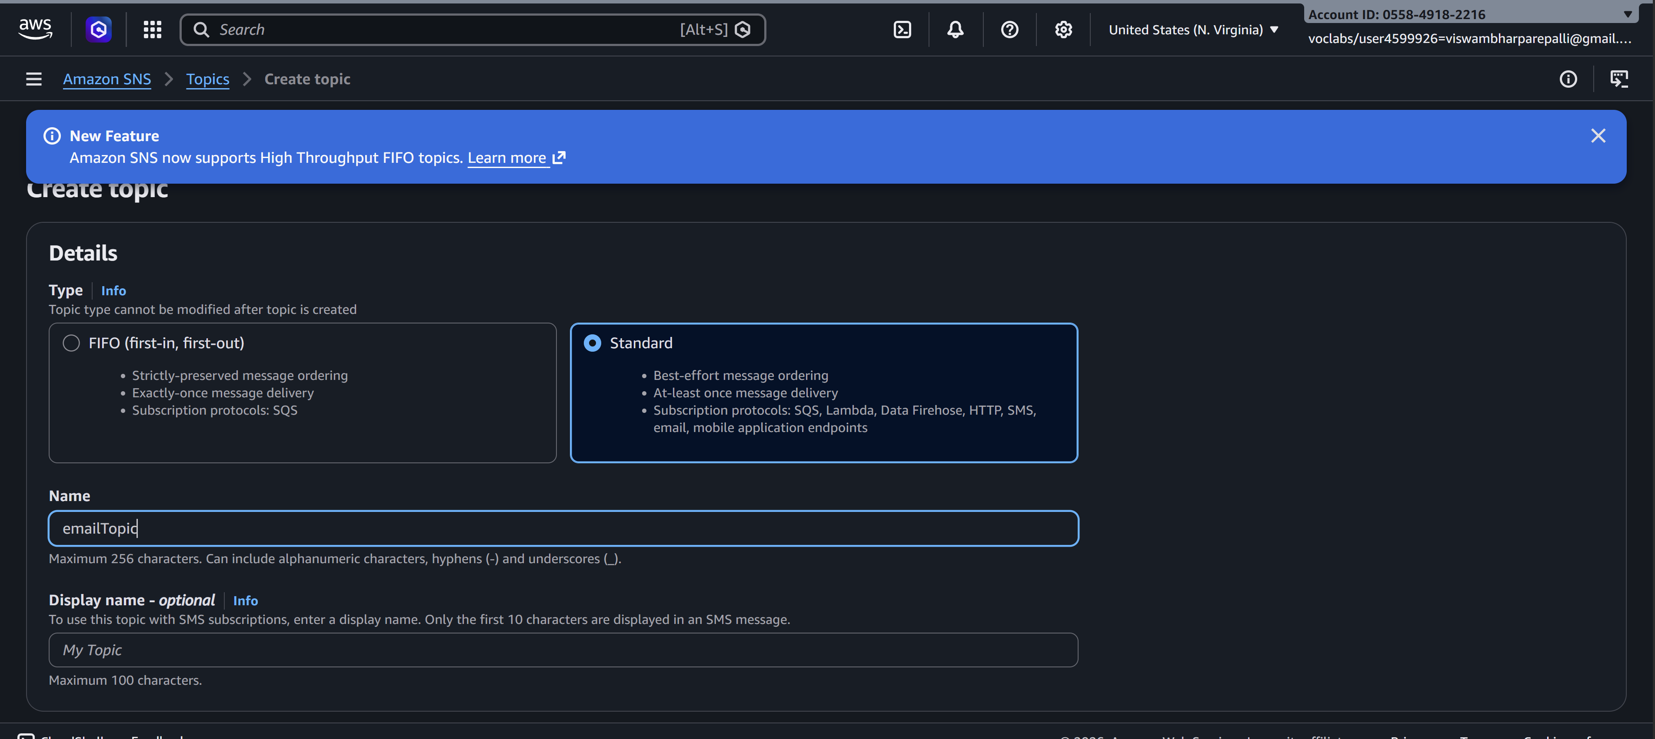

Step 2: Create Email Subscription
- Open your created topic
- Go to Subscriptions tab
- 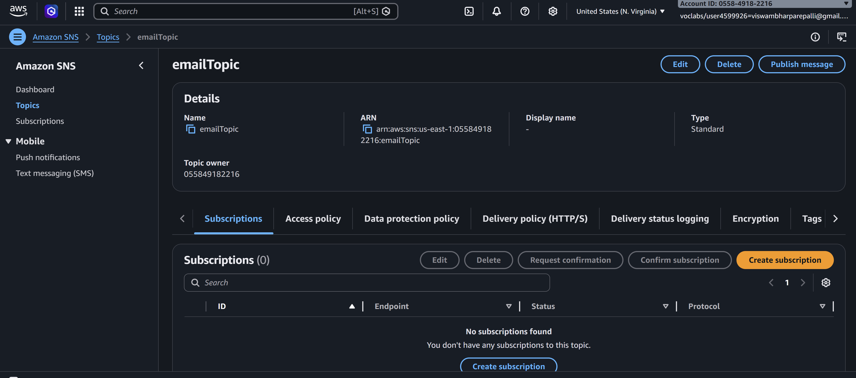
- Click Create subscription

Configure:
- Protocol → Select Email
- Endpoint → Enter your email address
- Click Create subscription
- 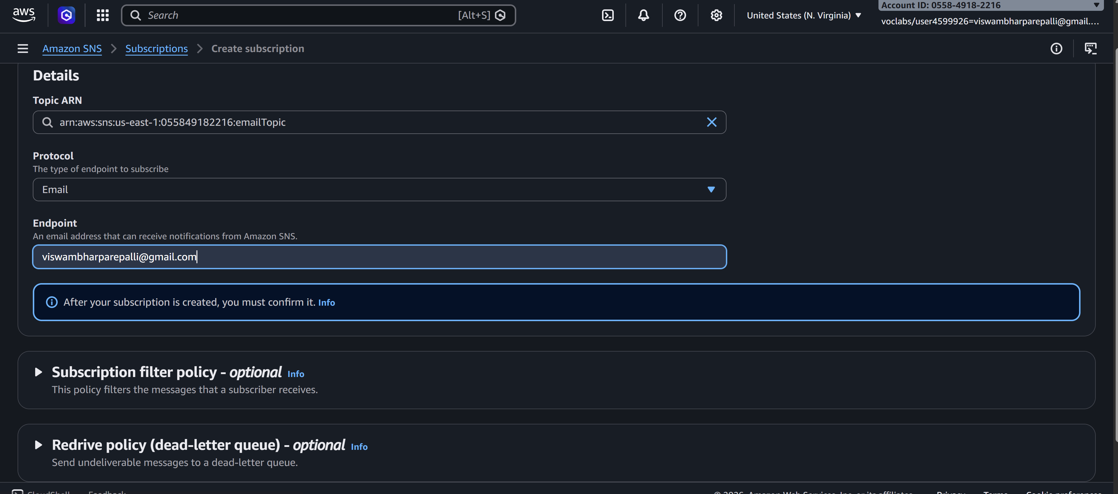

Step 3: Confirm Subscription
- Go to your email inbox
- You will receive a mail from Amazon SNS
- Click Confirm subscription
Now your email is successfully subscribed 🎉
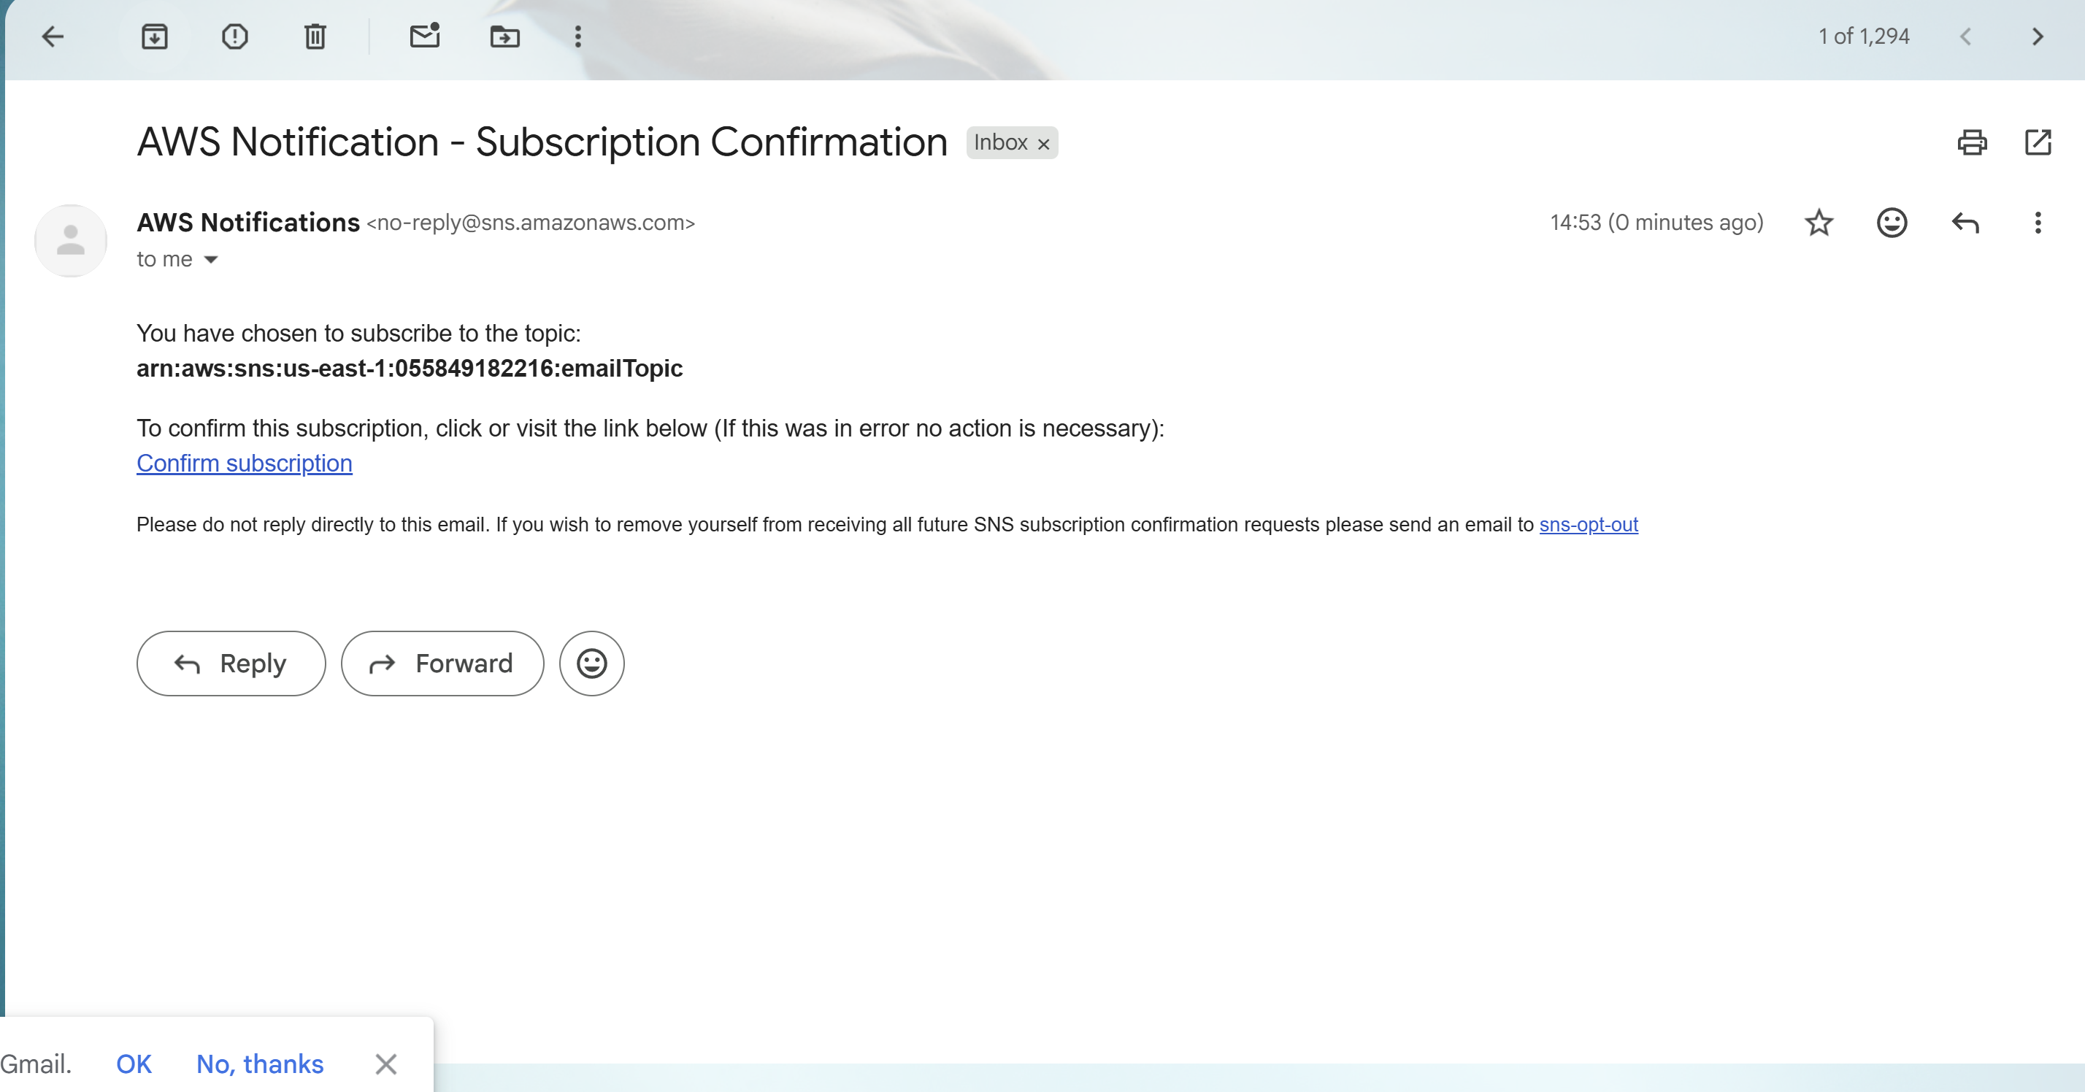

Step 4: Publish Test Message
- Open your SNS topic
- Click Publish message
- Add:
  - Subject → Test Mail
  - Message body → Hello this is SNS test
- Click Publish message
- 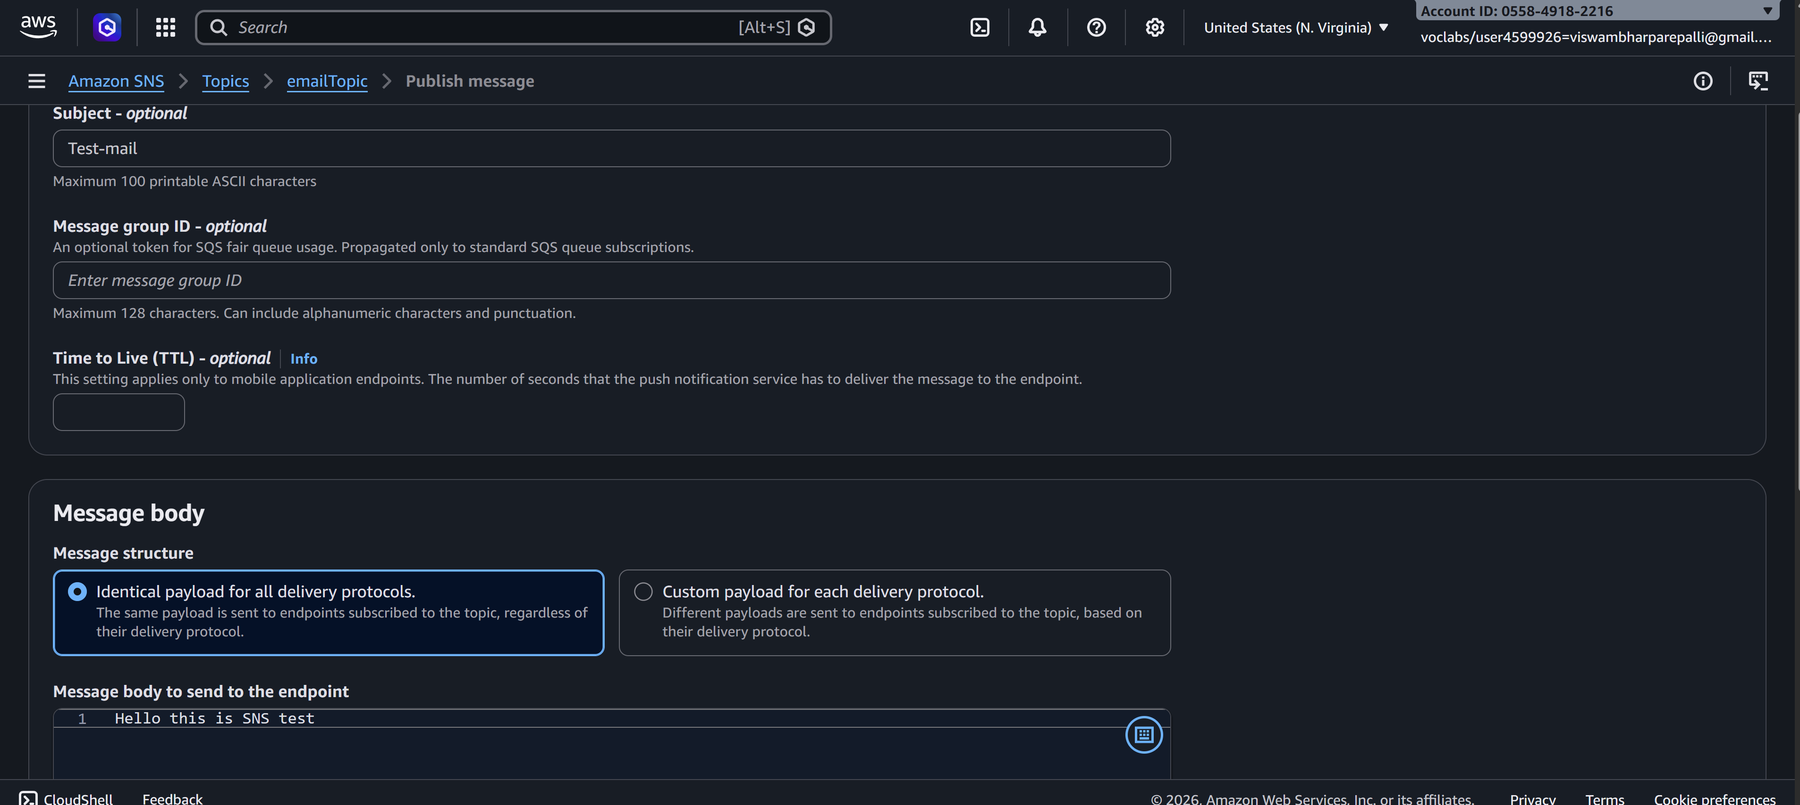
You will receive email notification.
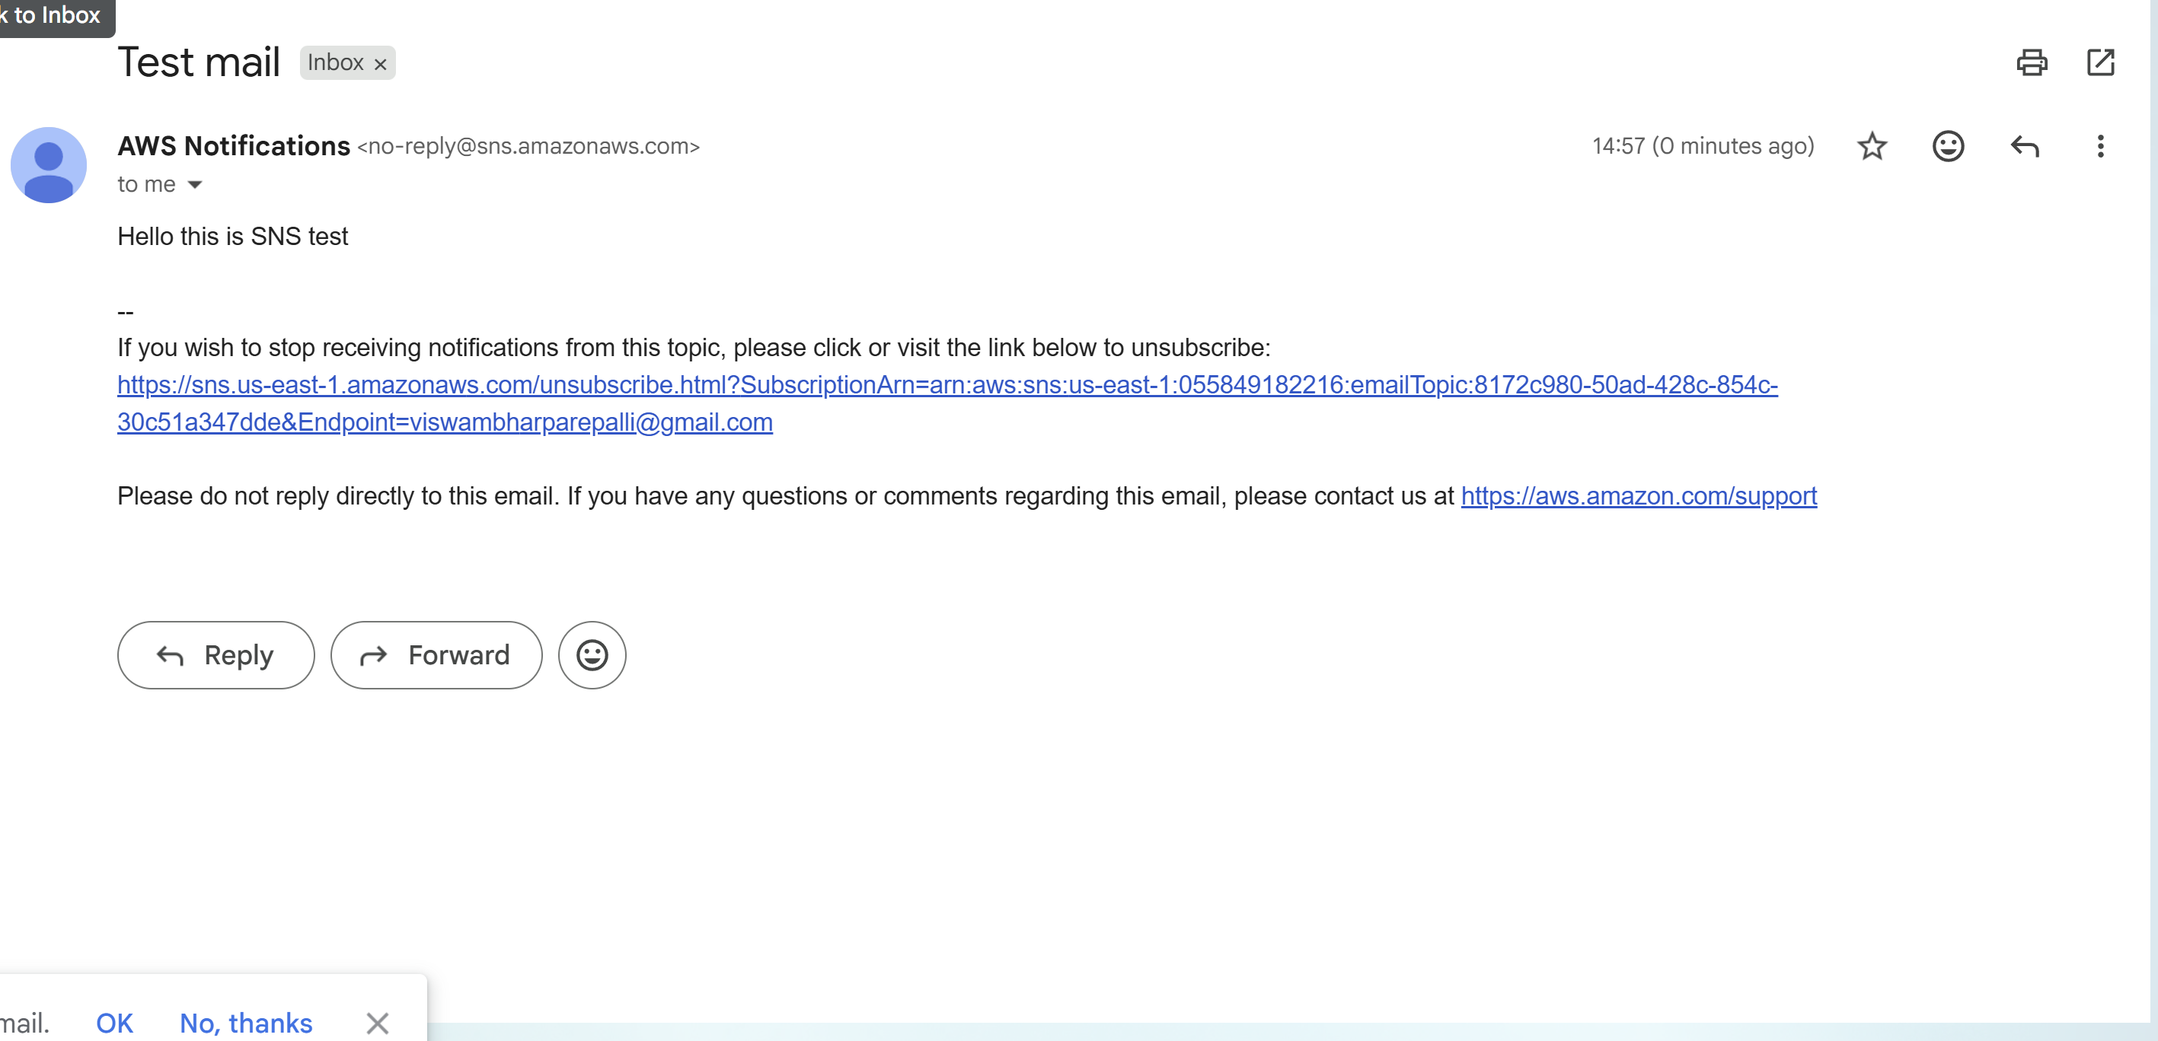

B) Trigger Email When S3 Object is Uploaded (S3 → SNS → Email)
Now we extend this setup:
Flow:
S3 Bucket → Event Notification → SNS Topic → Email

Step 1: Create S3 Bucket
- Search → S3
- Click Create bucket

Configure:
- Bucket name → my-upload-bucket-2026
- Choose Region (Important: Same region as SNS topic)
- Keep default settings (unless specific requirement)
- Click Create bucket
- 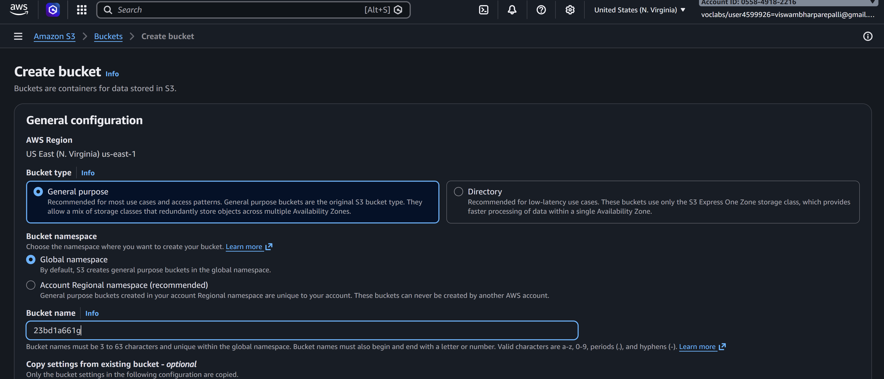
- 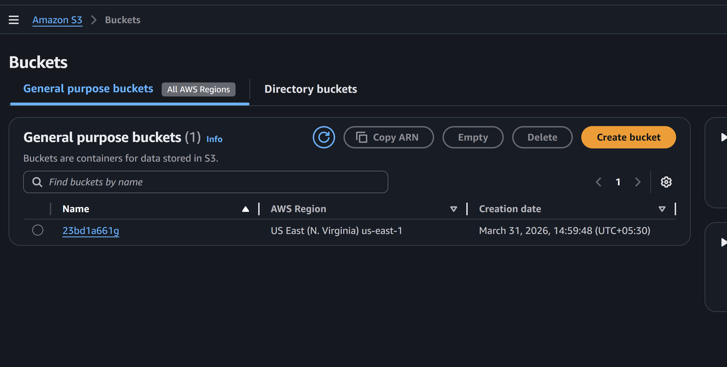

Step 2: Create SNS Topic (If not already created)
You can reuse the topic from Part A
OR create new topic like:
- Topic name → S3UploadNotification
Make sure email subscription is confirmed.
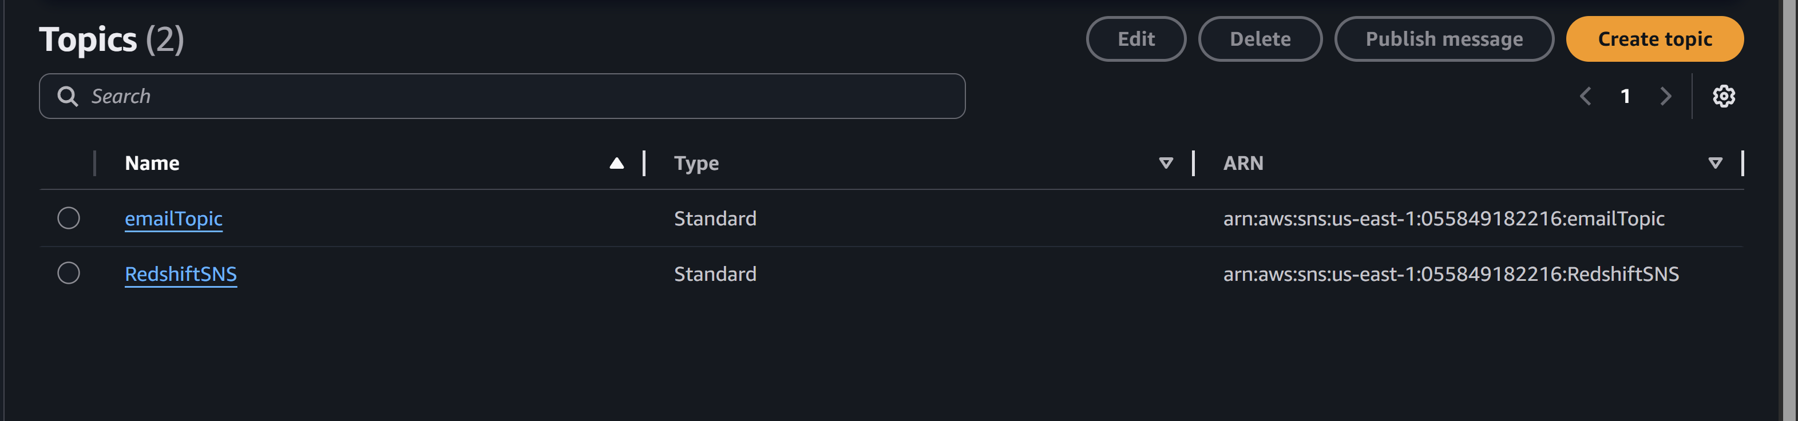

Step 3: Allow S3 to Publish to SNS (Access Policy)
- Open SNS Topic
- Go to Access policy
- Click Edit
Add permission for S3 to publish.
If using Basic Editor:
Access Policy that needs to be configured on SNS:
a) replace SNS topic ARN
b) Replace s3 bucket ARN
c) Replace account
{
"Version": "2012-10-17",
"Id": "example-ID",
"Statement": [
{
"Sid": "Example SNS topic policy",
"Effect": "Allow",
"Principal": {
"Service": "s3.amazonaws.com"
},
"Action": [
"SNS:Publish"
],
"Resource": "SNS topic ARN",
"Condition": {
"ArnLike": {
"aws:SourceArn": "s3 bucket ARN"
},
"StringEquals": {
"aws:SourceAccount": "account id"
}
}
}
]
}

(Modern AWS console often auto-generates this when configuring from S3)
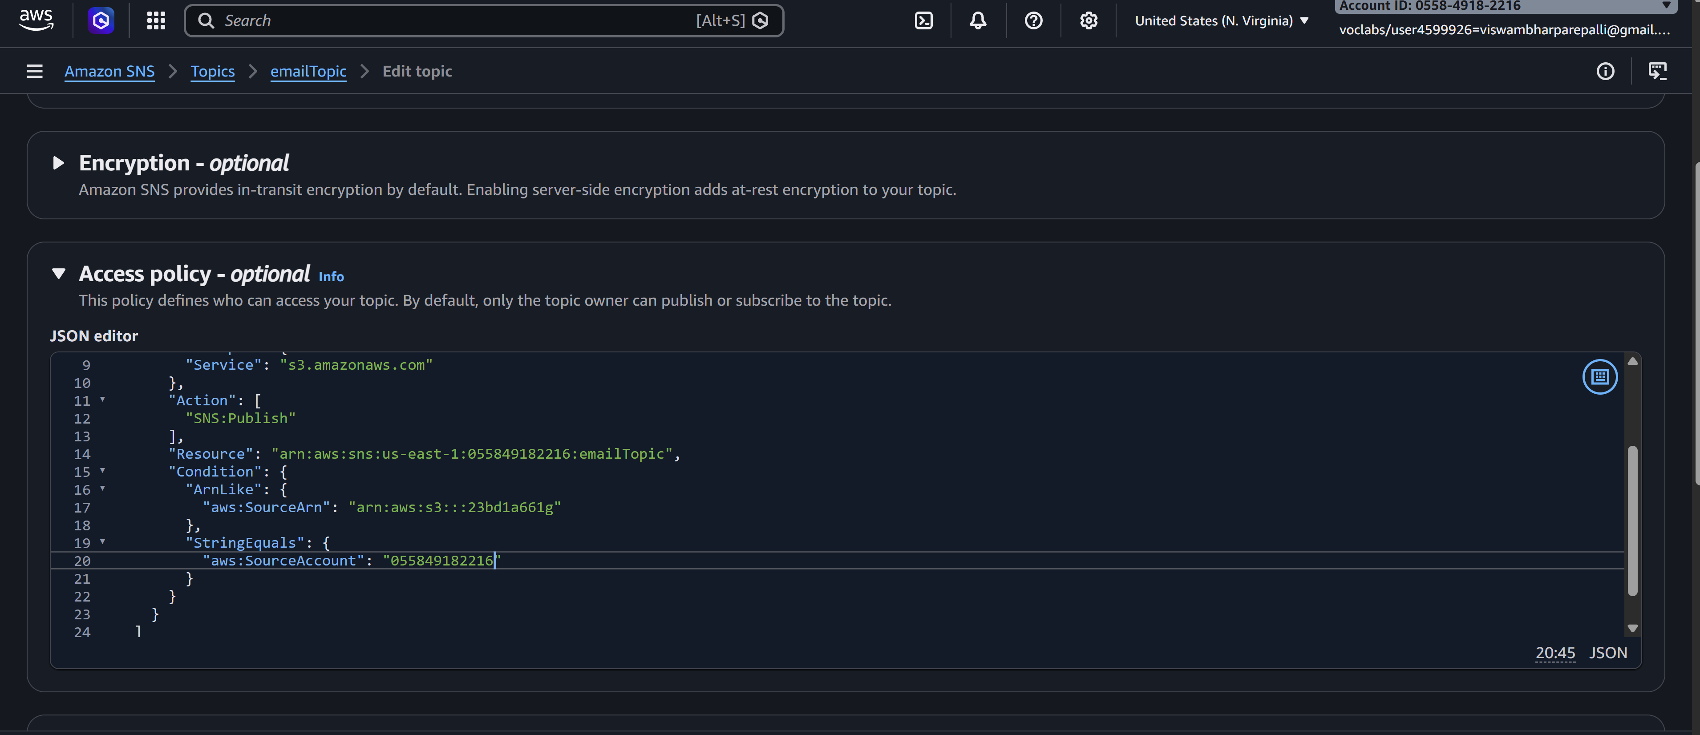
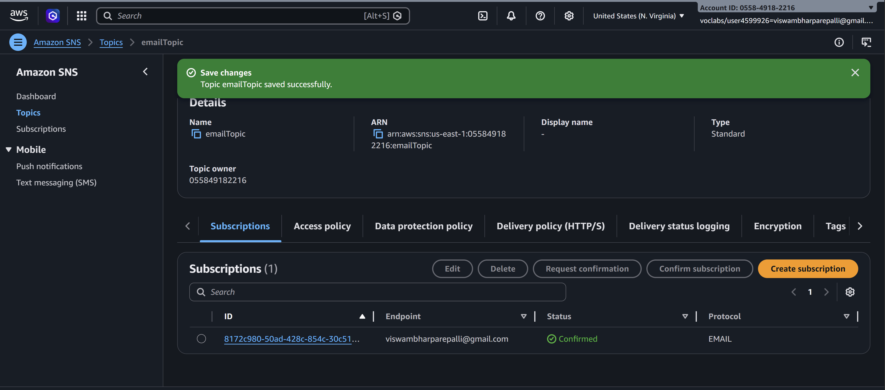

Step 4: Configure S3 Event Notification
- Open your S3 bucket
- Go to Properties
- Scroll to Event notifications
- Click Create event notification

Configure:
- Event name → UploadNotification
- Event types → Select:
  - All object create events
- Destination:
  - Select SNS topic
  - Choose your topic (S3UploadNotification)
- Click Save changes
- 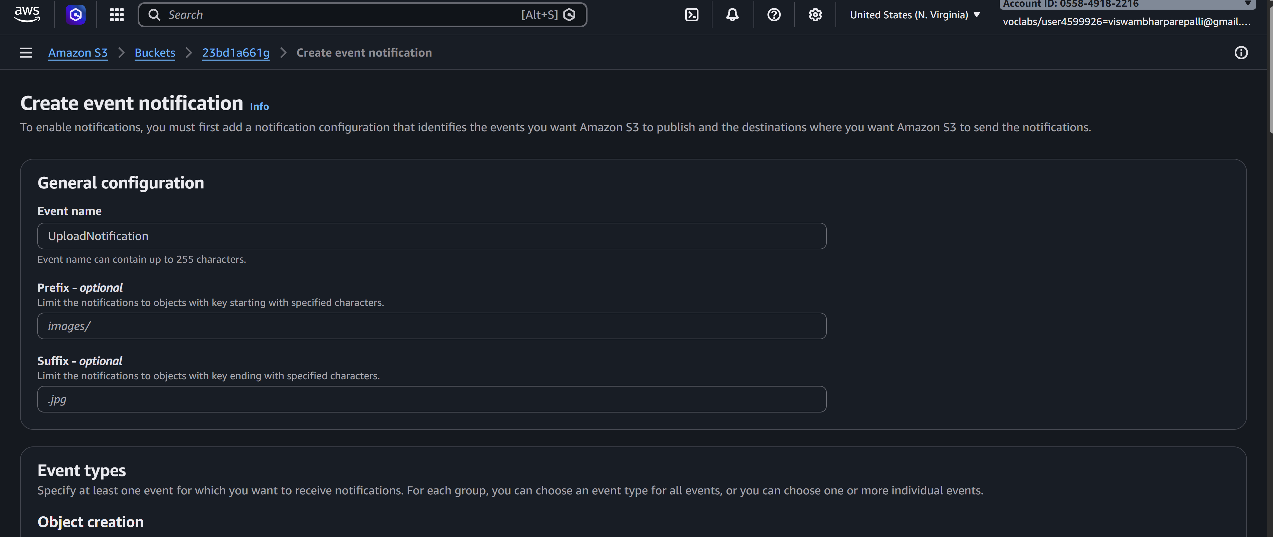
- 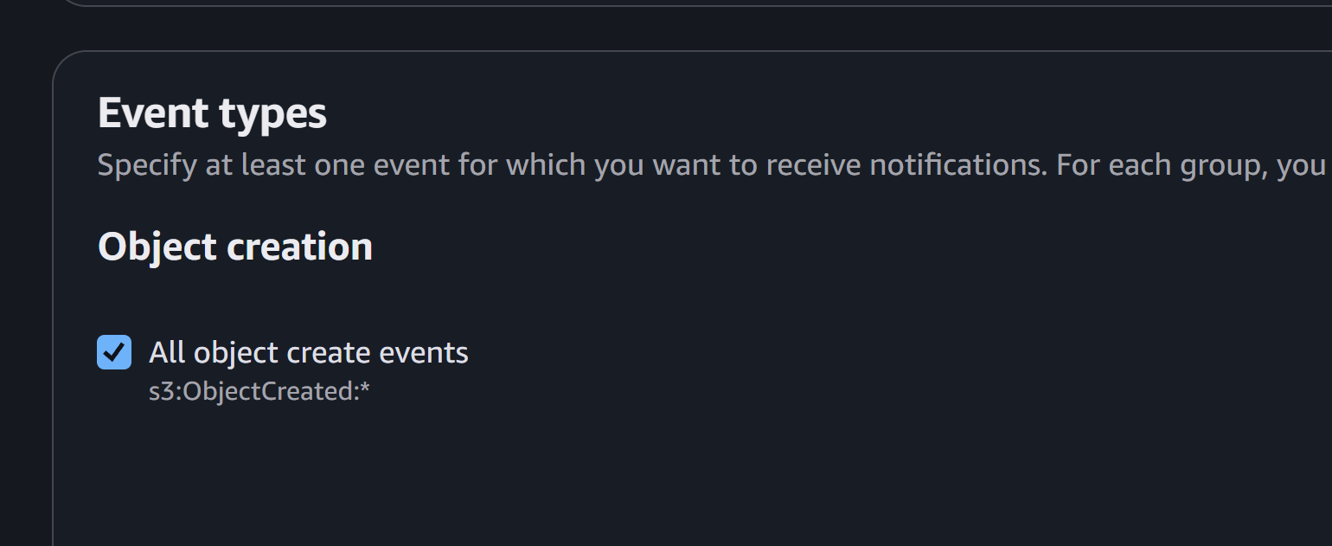
- 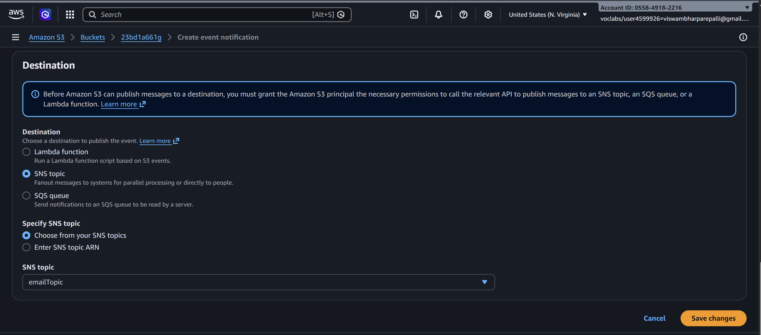

Step 5: Test It
- Upload any file into the S3 bucket
- 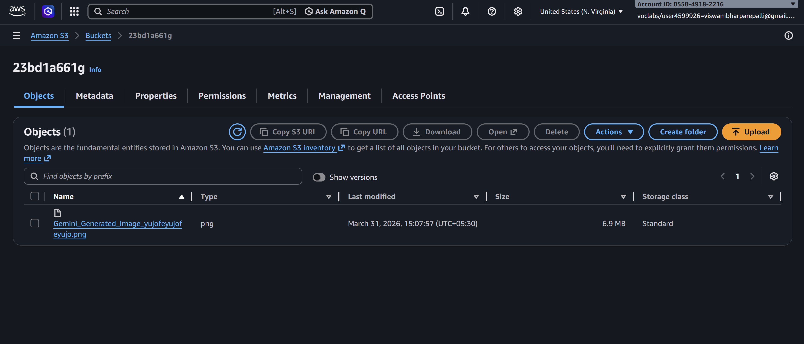
- After upload completes:
  - S3 triggers event
  - SNS receives publish request
  - SNS sends email
You will receive mail about object upload.
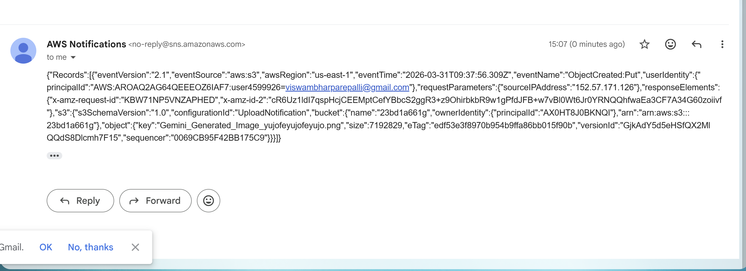

Simple Queue Service (SQS)

2) Create SQS Queue and Send Message
We will:
- Create an SQS Queue
- Send a message to the Queue
- Receive the message from the Queue

Step 1: Create SQS Queue
- Login to AWS Console
- In the search bar → Type SQS
- Open Amazon Simple Queue Service
- In the dashboard → Click Create queue
Configure:
• Type → Select Standard
• Name → MyQueue
• Leave other settings as default
- Click Create queue
Your SQS queue is now created successfully.
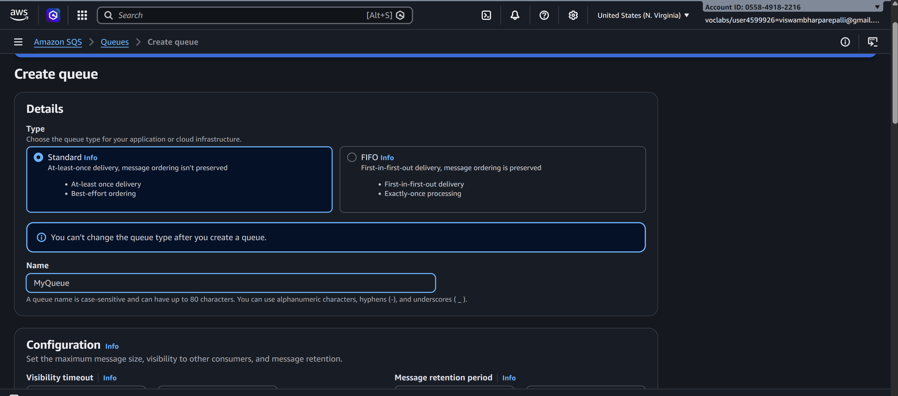

Step 2: Send Message to Queue
- Open the MyQueue queue
- Click Send and receive messages
- In the Message body, type:
Hello this is SQS test message
- Click Send message
Your message is now stored in the queue.
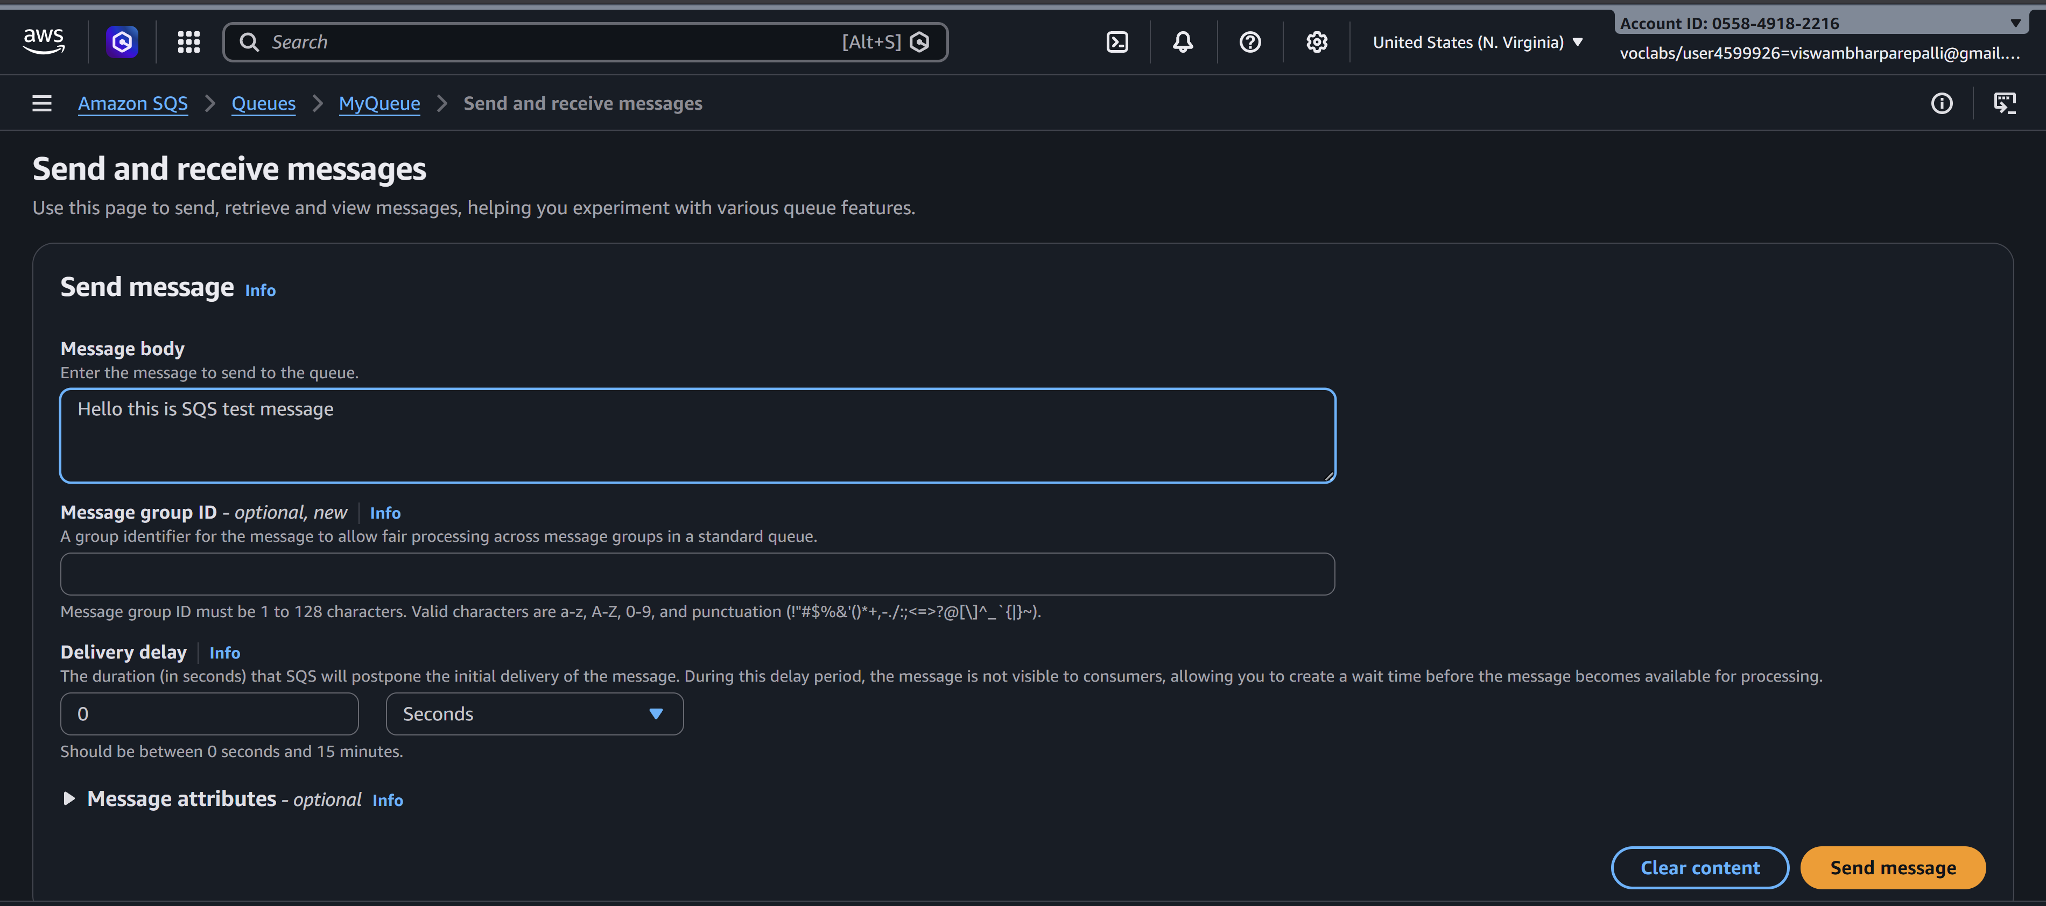

Step 3: Receive Message from Queue
- In the same page (Send and receive messages)
- Click Poll for messages
- 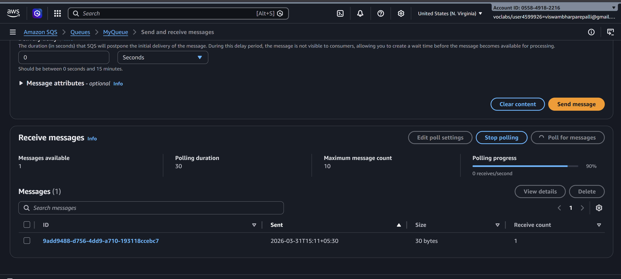
You will see the message displayed.
Example output:
Hello this is SQS test message
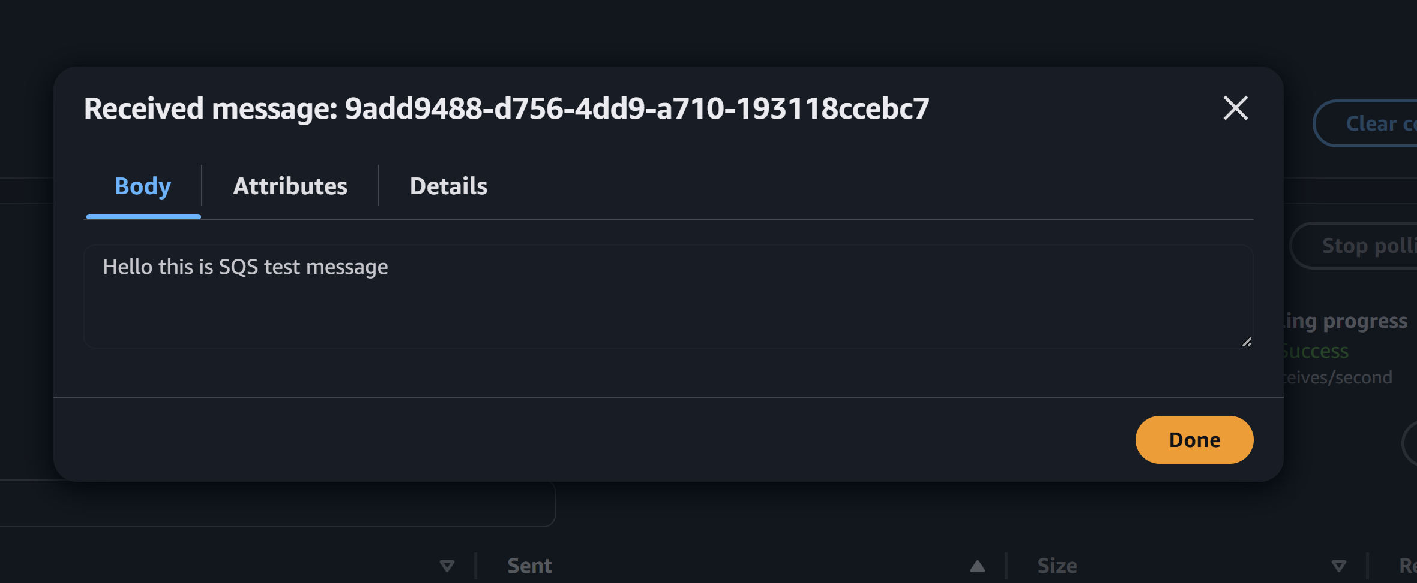
- After processing, click Delete message (optional)
- 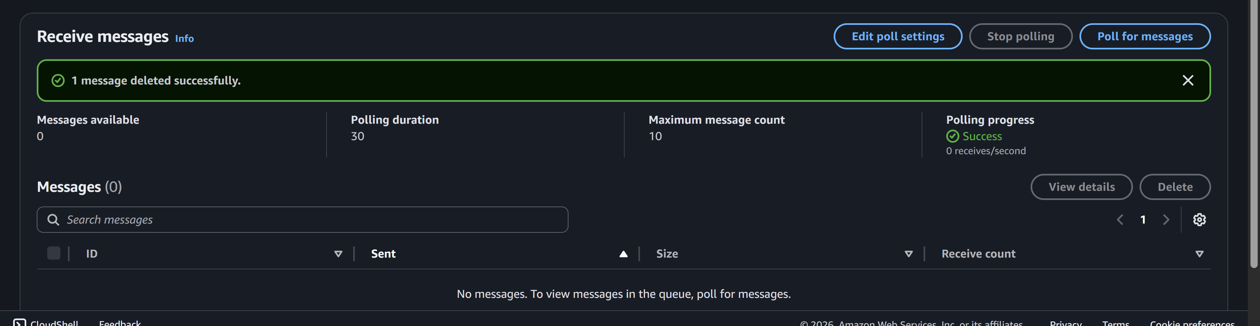

Result:
- SQS queue created
- Message sent successfully
- Message received from queue

3) S3 Bucket Event → SNS → SQS → Lambda Processing
S3 bucket event (like file upload) triggers SNS, which sends the notification to SQS. Then Lambda acts as the consumer and processes the message.
Services used:
• Amazon S3
• Amazon Simple Notification Service
• Amazon Simple Queue Service
• AWS Lambda

S3 → SNS → SQS → Lambda Architecture
S3 Bucket (File Upload)
↓
SNS Topic
↓
SQS Queue
↓
Lambda Function (Consumer)
When a file is uploaded, S3 sends an event notification to SNS, which forwards the message to SQS. The Lambda function then reads and processes the message from SQS.

Step 1: Create S3 Bucket
- Login to AWS Console
- Search S3
- Open Amazon S3
- Click Create bucket
Configure:
• Bucket name → mys3eventbucket123 (must be unique)
• Region → choose your region
Leave other settings default.
- Click Create bucket
- 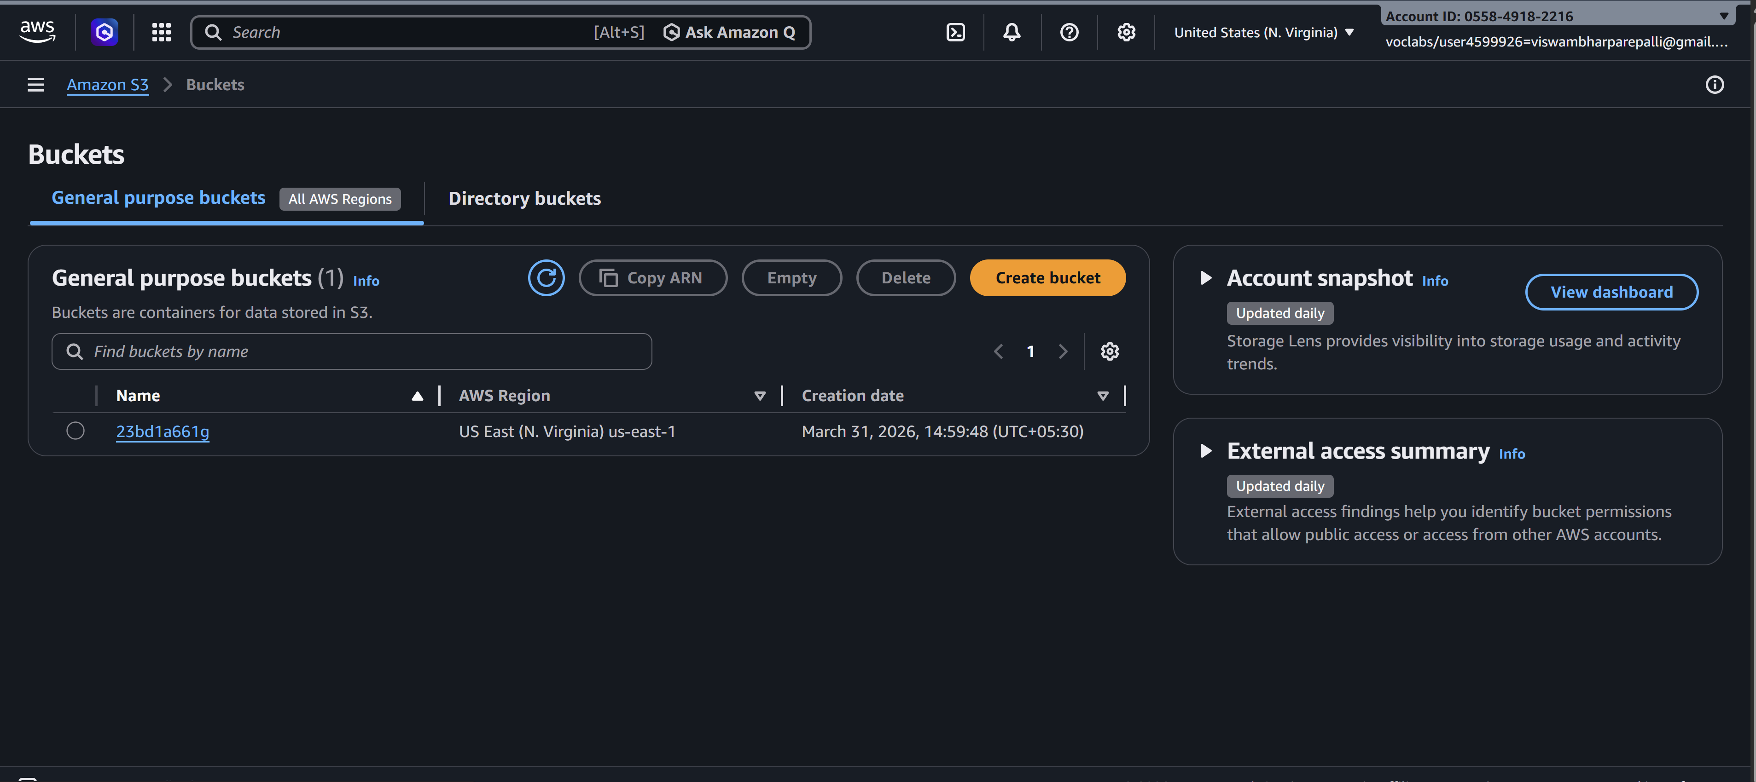

Step 2: Create SNS Topic
- Search SNS in AWS Console
- Open Amazon SNS
- Click Topics → Create topic
Configure:
• Type → Standard
• Name → MyS3SNSTopic
- Click Create topic
Copy the SNS Topic ARN.
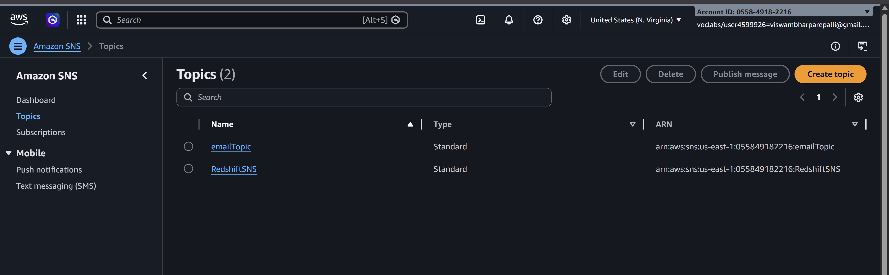

Step 3: Create SQS Queue
- Search SQS in AWS Console
- Open Amazon SQS
- Click Create queue
Configure:
• Type → Standard
• Name → MyS3Queue
- Click Create queue
Copy the Queue ARN.
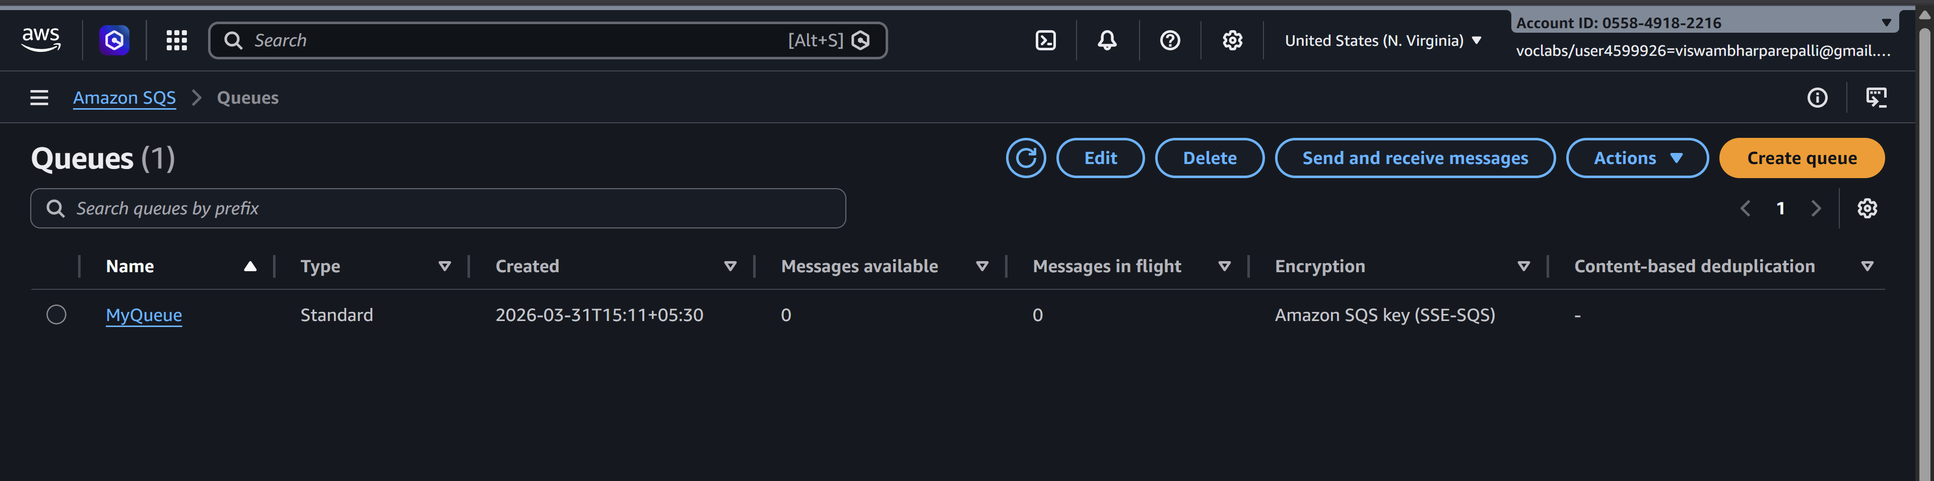

Step 4: Subscribe SQS to SNS
- Open MyS3SNSTopic
- Click Create subscription
Configure:
• Protocol → Amazon SQS
• Endpoint → Select MyS3Queue
- Click Create subscription
- 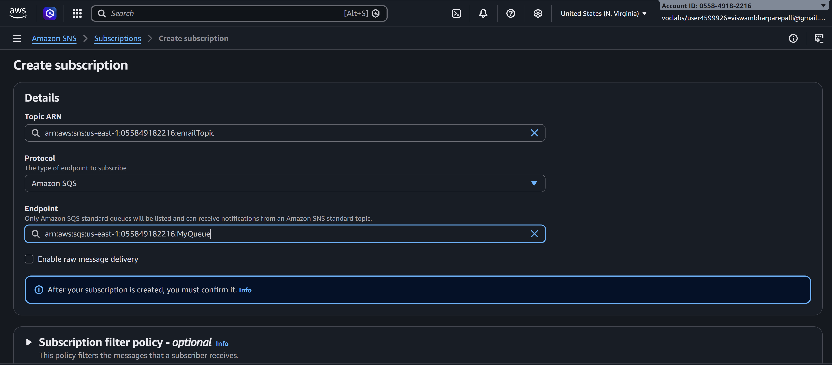
- 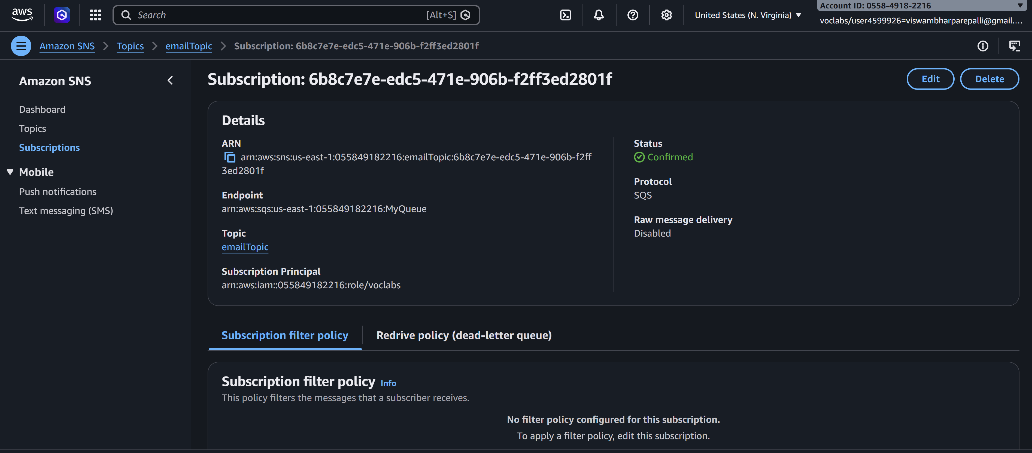

Step 5: Add Access Policy to SQS
Open MyS3Queue → Access Policy → Edit
Replace:
• SQS ARN
• SNS ARN
{
"Statement": [
{
"Effect": "Allow",
"Principal": {
"Service": "sns.amazonaws.com"
},
"Action": "sqs:SendMessage",
"Resource": "SQS ARN",
"Condition": {
"ArnEquals": {
"aws:SourceArn": "SNS ARN"
}
}
}
]
}
Click Save.
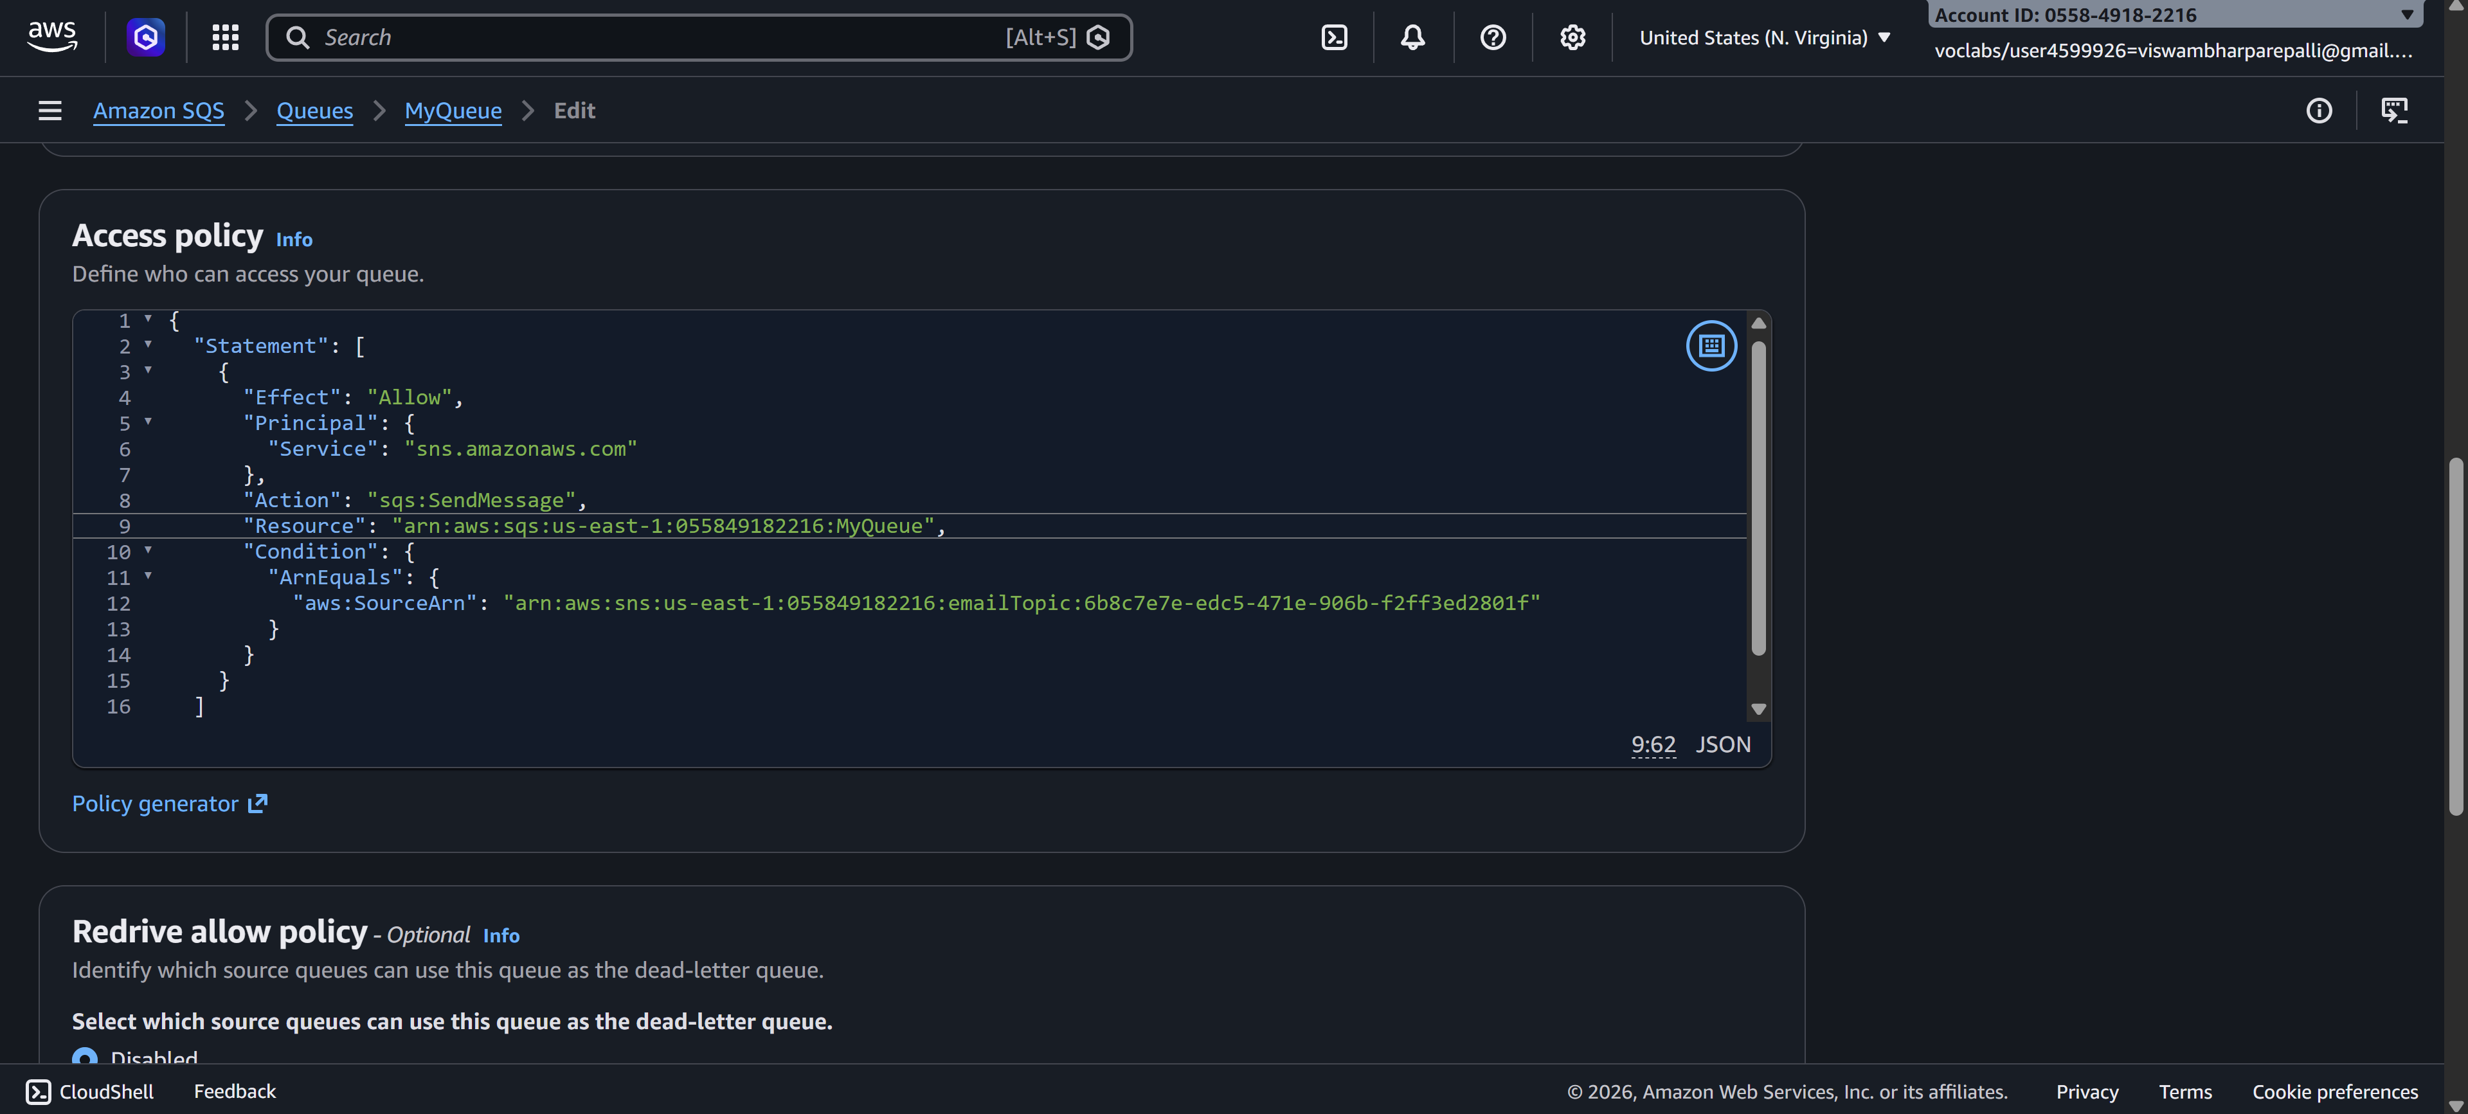

Step 6: Add Access Policy to SNS
Open SNS Topic → Edit access policy
Replace:
• SNS topic ARN
• S3 bucket ARN
• Account ID
{
"Version": "2012-10-17",
"Id": "example-ID",
"Statement": [
{
"Sid": "Example SNS topic policy",
"Effect": "Allow",
"Principal": {
"Service": "s3.amazonaws.com"
},
"Action": [
"SNS:Publish"
],
"Resource": "SNS topic ARN",
"Condition": {
"ArnLike": {
"aws:SourceArn": "S3 bucket ARN"
},
"StringEquals": {
"aws:SourceAccount": "Account ID"
}
}
}
]
}
Save the policy.
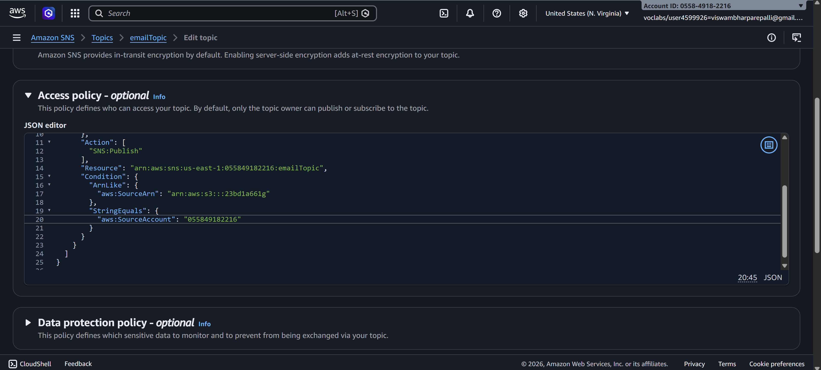
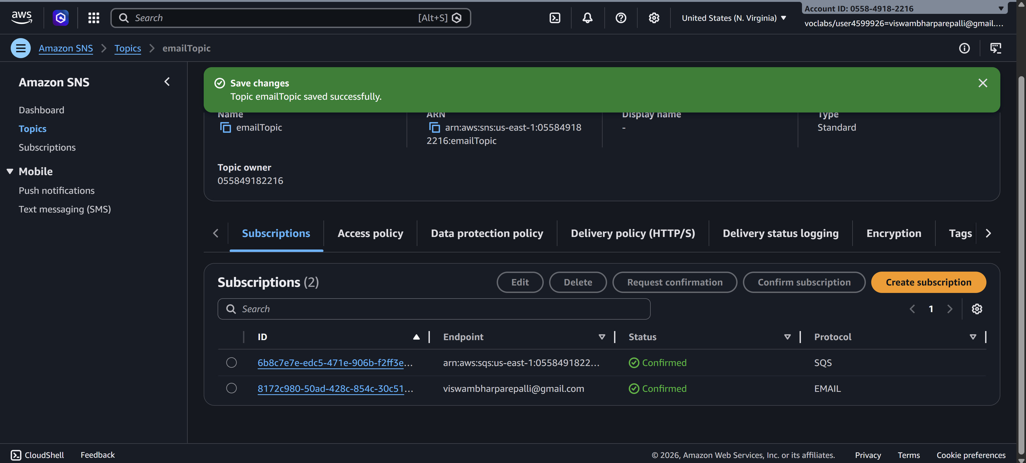

Step 7: Configure S3 Event Notification
- Open S3 Bucket (mys3eventbucket123)
- Go to Properties
- Scroll to Event notifications
Click Create event notification
Configure:
• Event name → S3UploadEvent
• Event type → All object create events
Destination:
• SNS Topic → MyS3SNSTopic
Click Save changes.
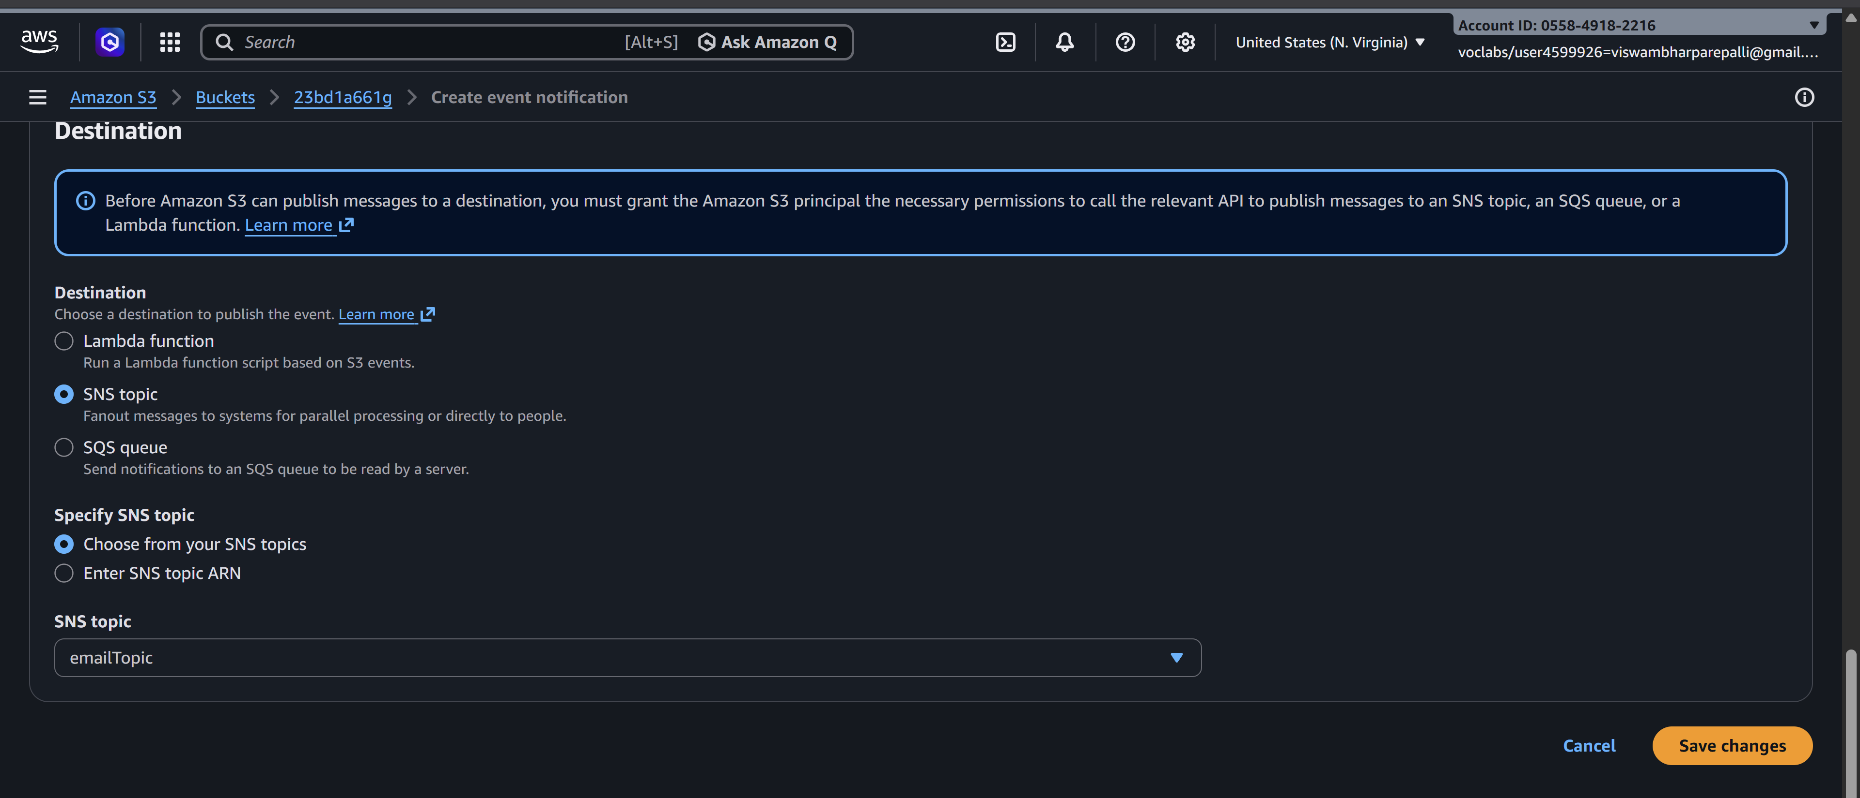

Step 8: Test the Architecture
- Open the S3 bucket
- Click Upload file
- Upload any file (example: test.txt)
Now:
File Upload → S3
↓
Notification → SNS
↓
Message → SQS
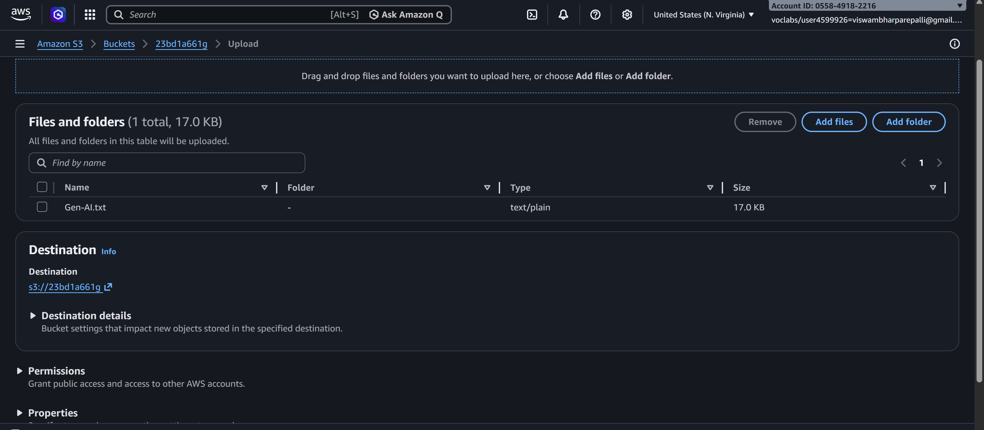

Step 9: Verify Message in SQS
- Open MyS3Queue
- Click Send and receive messages
- Click Poll for messages
You will see the S3 event notification message.
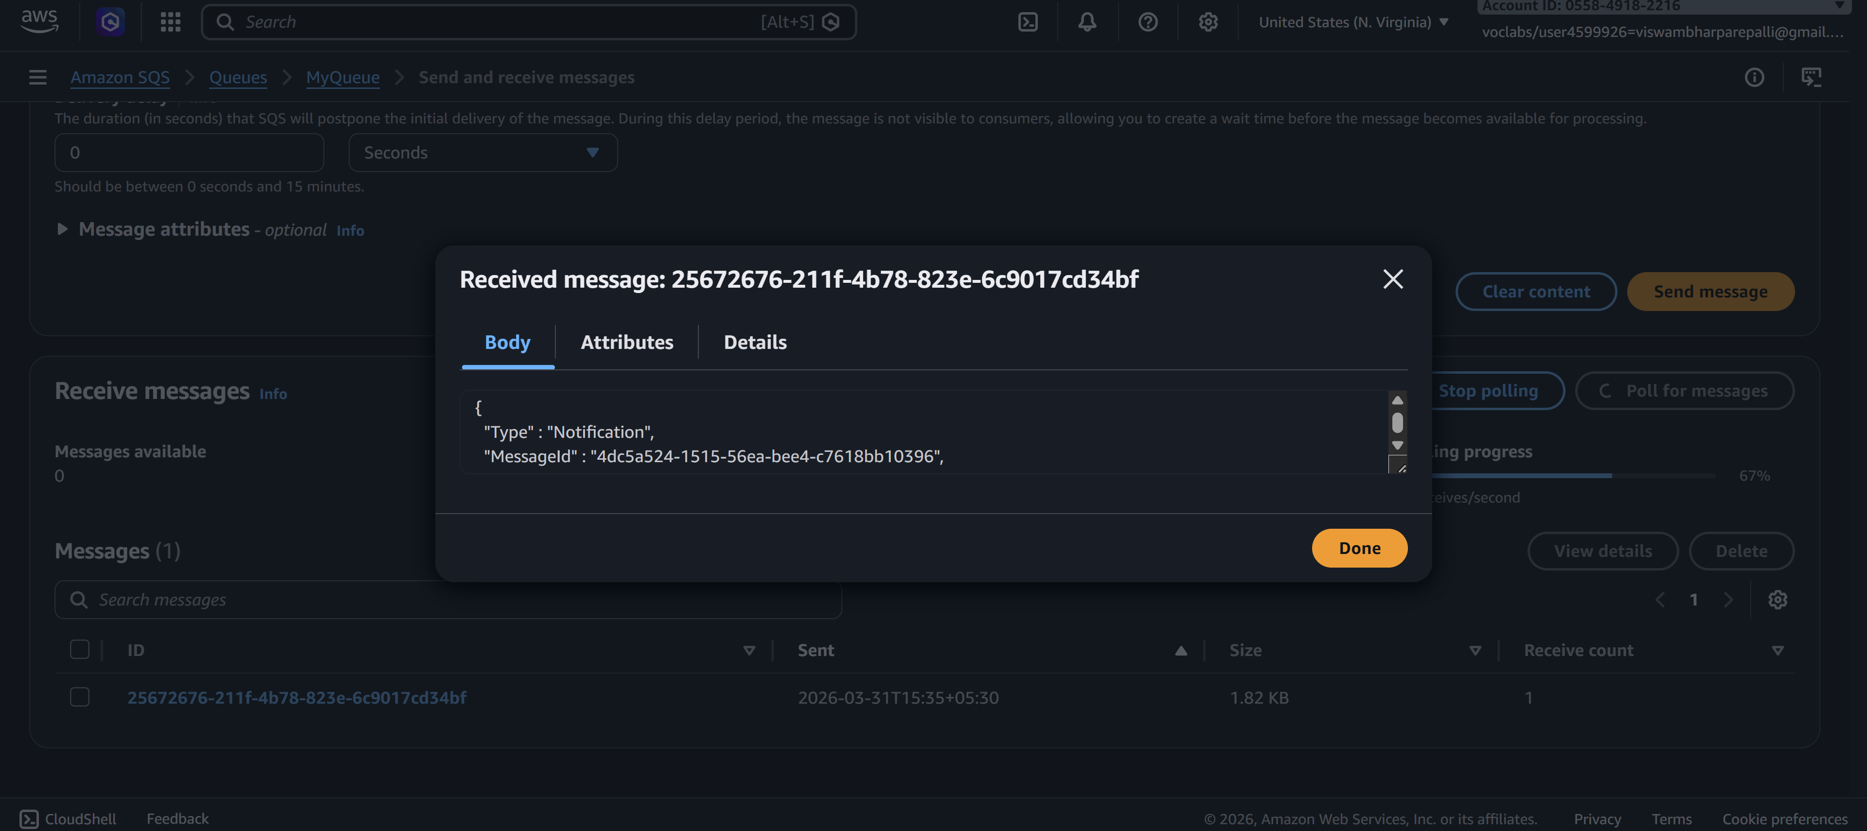

Step 10: Configure Lambda as Consumer
Now configure Lambda to automatically process messages from SQS.
Create Lambda Function
- Search Lambda in AWS Console
- Open AWS Lambda
- Click Create Function
Configure:
• Author from scratch
• Function name → SQSConsumerFunction
• Runtime → Python 3.x
Click Create function
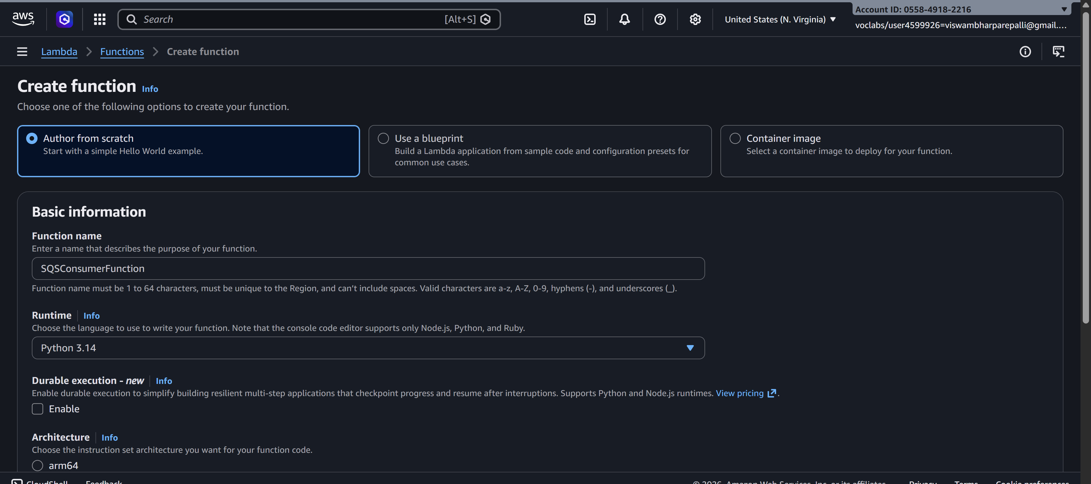

Add SQS Trigger
- Open SQSConsumerFunction
- Click Add Trigger
- Select SQS
- Choose MyS3Queue
Click Add
Now Lambda will automatically read messages from SQS.
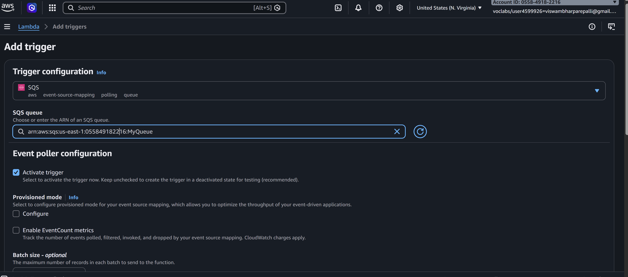

Lambda Code
Replace code with:
def lambda_handler(event, context):

for record in event['Records']:
print("Message received from SQS:")
print(record['body'])

return {
'statusCode': 200,
'body': 'Message processed successfully'
}
Click Deploy.
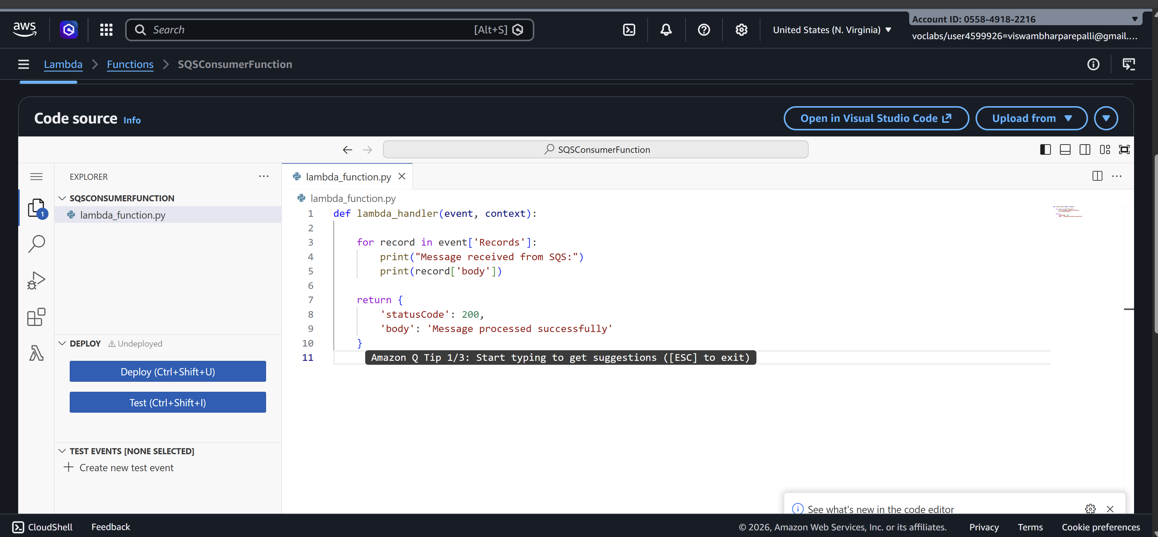

Final Architecture
User uploads file
↓
Amazon S3
↓
SNS Topic
↓
SQS Queue
↓
Lambda Function (Consumer)
↓
Processing / Logs / Database

Result
When a file is uploaded to S3:
- S3 sends a notification to SNS
- SNS forwards the message to SQS
- SQS stores the message
- Lambda automatically reads and processes the message
This creates a serverless event-driven architecture commonly used in real cloud applications.
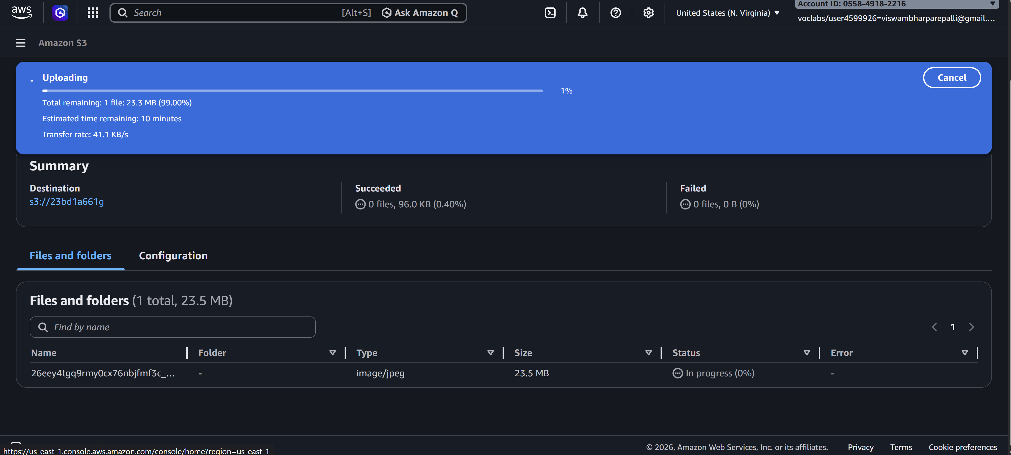
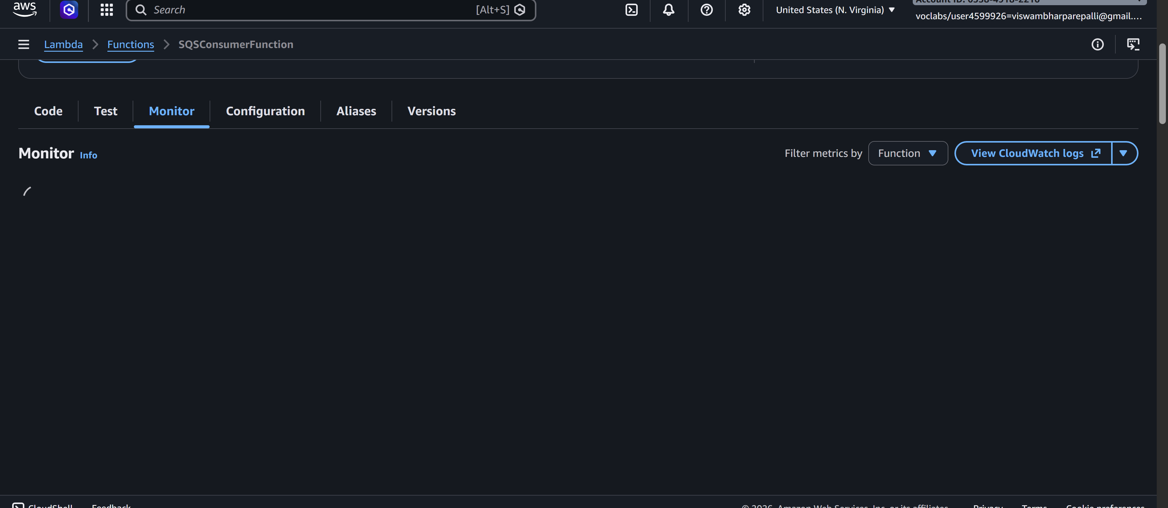
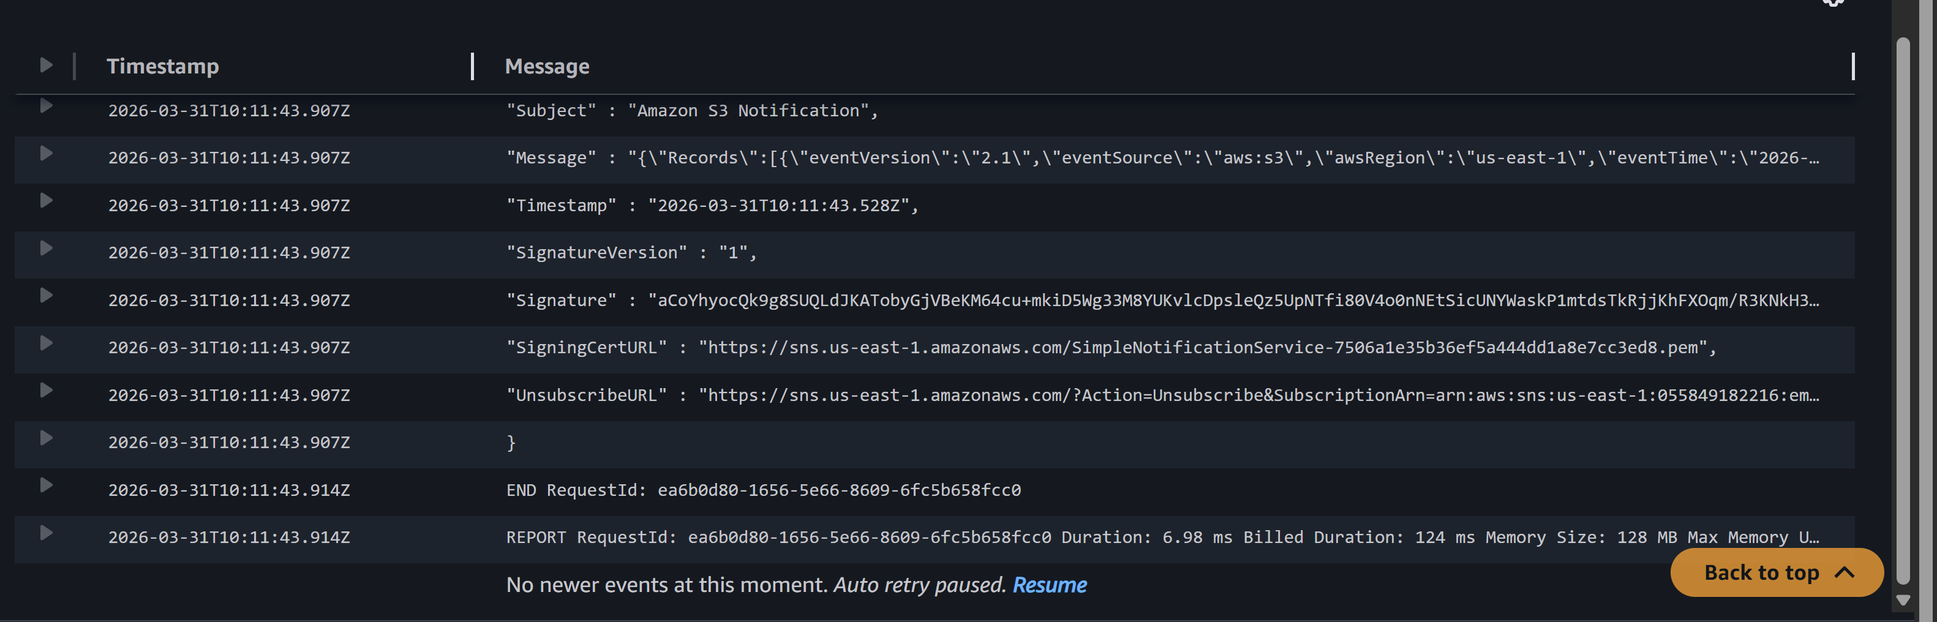

Scenario Based Questions (SNS, SQS, S3-SNS-SQS-Lambda)
- A company wants to send notifications to multiple users whenever an important system event occurs. The same message must be delivered to email, SMS, and application subscribers simultaneously. Which AWS service can be used to implement this publish-subscribe messaging system?
Answer:
Amazon Simple Notification Service (Amazon SNS) can be used. SNS supports the publish-subscribe messaging model, allowing a message published to a topic to be delivered simultaneously to multiple subscribers such as email, SMS, Lambda functions, HTTP endpoints, or SQS queues.

- A developer created an SNS topic and added an email subscription, but the subscriber is not receiving any notifications. What could be the possible reason for this issue?
Answer:
The most common reason is that the email subscription has not been confirmed. When an email subscription is created, AWS sends a confirmation email. The subscriber must click the confirmation link before notifications can be received.

- An organization wants to automatically notify administrators via email whenever a new file is uploaded to an S3 bucket. How can this be implemented using AWS services?
Answer:
This can be implemented by configuring S3 event notifications. The S3 bucket can be configured to trigger an SNS topic whenever a file upload event occurs. Administrators subscribe to the SNS topic using their email addresses so they receive notifications whenever a new file is uploaded.

- A developer configured an S3 bucket to trigger an SNS notification on file upload, but the message is not reaching the SNS topic. What configuration or permission issue might cause this problem?
Answer:
The issue may occur if the S3 bucket does not have permission to publish messages to the SNS topic. The SNS topic policy must allow the S3 service to perform the SNS:Publish action.

- A company wants to store incoming messages temporarily so that applications can process them later without losing data even if the system is busy. Which AWS messaging service should be used for this requirement?
Answer:
Amazon Simple Queue Service (Amazon SQS) should be used. SQS stores messages in a queue until they are processed by consumers, ensuring that messages are not lost even when the system is busy.

- A developer sends messages to an SQS queue, but when checking the queue no messages appear. What possible reasons could cause this issue?
Answer:
Possible reasons include:
- The messages are being consumed immediately by a consumer application.
- The queue URL used in the application is incorrect.
- Messages are sent to a different queue or AWS region.
- The visibility timeout hides messages that are currently being processed.

- A company wants to process thousands of messages coming from different applications without overloading the processing system. How does Amazon SQS help in handling this situation?
Answer:
Amazon SQS acts as a buffer between application components. Messages are stored in the queue and processed at a controlled rate by consumer services. This prevents the processing system from being overloaded and allows scalable asynchronous processing.

- A developer wants to ensure that messages are processed automatically from an SQS queue without manually polling the queue. Which AWS service can be configured to automatically consume messages from SQS?
Answer:
AWS Lambda can be configured with an SQS trigger. Lambda automatically polls the queue and invokes the function whenever messages are available.

- An application uploads files to S3, and the company wants the upload event to trigger a workflow that sends notifications and processes the message later. How can this be designed using S3, SNS, SQS, and Lambda?
Answer:
The architecture can work as follows:
- Files are uploaded to Amazon S3.
- S3 triggers an event notification to an SNS topic.
- The SNS topic distributes the message to multiple subscribers such as email or SQS.
- Messages are stored in an SQS queue.
- AWS Lambda reads messages from SQS and processes them asynchronously.

- A developer configured an SNS topic to send messages to an SQS queue, but the queue is not receiving any messages. What policy configuration might be missing?
Answer:
The SQS queue policy may not allow the SNS topic to send messages. The queue policy must include permission allowing the SNS topic to perform the sqs:SendMessage action.

- A company wants to decouple its application components so that failures in one component do not affect others. Which AWS service combination can be used to implement loosely coupled communication?
Answer:
Amazon SNS and Amazon SQS can be used together. SNS distributes messages to multiple services, while SQS queues store messages and allow components to process them independently, enabling loosely coupled architecture.

- A Lambda function is configured to process messages from an SQS queue, but the function is not being triggered. What possible configuration issue might cause this problem?
Answer:
Possible issues include:
- The SQS queue is not configured as an event source for the Lambda function.
- The Lambda function lacks permissions to read from the SQS queue.
- The queue and Lambda function are in different regions.

- An organization wants to ensure that uploaded files in S3 trigger notifications, store messages reliably, and process them asynchronously. Which serverless architecture using AWS services can achieve this?
Answer:
A suitable serverless architecture is:
S3 → SNS → SQS → Lambda
S3 generates events, SNS distributes notifications, SQS stores messages reliably, and Lambda processes them asynchronously.

- A developer wants to monitor the processing of messages handled by a Lambda function triggered by SQS. Which AWS service can be used to view logs and troubleshoot the function execution?
Answer:
Amazon CloudWatch can be used. CloudWatch Logs stores Lambda execution logs and helps monitor, debug, and troubleshoot function behavior.

- A company wants to build a fully serverless event-driven system where file uploads automatically trigger notifications and background processing without managing servers. Which AWS services can be combined to build this architecture?
Answer:
The architecture can combine Amazon S3, Amazon SNS, Amazon SQS, and AWS Lambda. S3 triggers events, SNS distributes notifications, SQS queues messages, and Lambda processes them without managing servers.

- A company wants to send a notification to multiple applications whenever a new order is placed in their system. Each application should receive the same message and process it independently. Which AWS service can be used to implement this publish-subscribe communication model?
Answer:
Amazon Simple Notification Service (Amazon SNS) can be used. It enables publish-subscribe messaging where one message is delivered to multiple subscribers.

- A developer configured an SNS topic and connected it to an SQS queue, but the messages published to SNS are not appearing in the queue. What configuration or permission might be missing in this setup?
Answer:
The SQS queue policy may not allow the SNS topic to send messages. The policy must grant permission to the SNS topic to perform the sqs:SendMessage action.

- An application generates a large number of events, and the development team wants to ensure that these events are stored safely until they are processed by another service. Which AWS service can be used to reliably store and deliver these messages?
Answer:
Amazon Simple Queue Service (Amazon SQS) can be used. It provides reliable message storage and ensures messages remain in the queue until processed.

- A company uploads files to an S3 bucket and wants to process these files using Lambda, but only after the messages are safely stored to avoid data loss during high traffic. Which AWS architecture using SNS and SQS can help achieve this requirement?
Answer:
The architecture can be:
S3 → SNS → SQS → Lambda
S3 triggers an SNS notification, SNS sends messages to SQS, SQS stores them reliably, and Lambda processes the messages asynchronously.

- A developer notices that messages remain in an SQS queue even after being processed by a Lambda function. What configuration or step might be missing to ensure messages are removed after processing?
Answer:
The Lambda function may not be deleting the message after processing. Messages must be deleted from the queue after successful processing using the DeleteMessage action, otherwise they remain in the queue and may be processed again.

